Tactran Active Travel Behaviour Change and Access to Bikes

Invitation for Expression of Interest (EoI)

Cluster 3 – Dundee/Angus

Introduction
Please use this form to submit an Expression of Interest (EoI) to the Tactran Behaviour Change and Access to Bikes Initiative. Before completing this form, please read this full document which provides further information on the process and the clusters approach taken. When complete, please email this form to info@tactran.gov.uk by the closing date of 13/03/2024.
Cluster Name: | Cluster 3 - Dundee/Angus
Areas covered: | Dundee and Angus near existing NCN/Green Circular
Where you wish to submit an EOI for more than one project, please submit a separate form for each project (note that projects can cover more than one cluster/programme area). For further information on the EOI process, please see Section 6.
This form is for Cluster 3, as noted below. For the other cluster areas, there is a separate information sheet. The EOI form can be found in Appendix A.

Background
In line with Tactran’s draft RTS (for submission to the Cabinet Secretary for Transport) this fund is a key part of active travel behaviour change in the Tactran region.
The following sections have been prepared to support you in submitting an EoI to deliver projects in Cluster 3, thus supporting Tactran’s wider Behaviour Change and Access to Bikes programme. Please read this information carefully before submitting an EoI, as it contains important information on eligibility and timescales. It is also important to note that funding is contingent on Transport Scotland funding being awarded to Tactran for the 2024/25 financial year.
The Tactran region has delivered, and continues to deliver, high quality active travel infrastructure. Tactran recently developed a Regional Active Travel Network Strategy, and local active travel networks and projects are being proposed throughout each of the local authorities and national parks. Tactran has worked closely with each of the local authorities, Dundee City Council, Angus Council, Perth & Kinross Council and Stirling Council, to develop a behaviour change action plan that is focused around existing and planned infrastructure. This is to ensure that active travel is being promoted within communities where there is viable active travel infrastructure which people can be using, to demonstrate a change in modal shift. The Tactran Active Travel Web Map Database has been utilised to help identify geographical areas within the region where this infrastructure exists, where there are trip attractors such as schools and workplaces, and where there are disadvantaged communities that would benefit from a range of behaviour change initiatives. This approach has allowed clusters to be identified where behaviour change can be targeted. This summary sheet refers to Cluster 3 - Dundee/Angus.
It is proposed that, within the areas around this infrastructure, behaviour change initiatives are undertaken with the whole community, which includes schools, workplaces, and the wider population. This is considered to be the best approach to generate the required impact of encouraging modal shift to active and sustainable modes and reducing vehicle kilometres. This approach will enable Tactran and the local authorities to monitor and evaluate the impact within the clusters for both the infrastructure and behaviour change initiatives in tandem.
With regards to the timescale of these initiatives, they will run until the end of financial year 2024/25 and all projects should be delivered within the 2024/25 financial year. In a years’ time, if successful, this process can then be replicated in other areas throughout the region as the infrastructure networks and projects expand, adapting and improving projects where possible based on lessons learned from the 2024/25 programme.

Organisation Eligibility
We are accepting EoIs from any organisation that demonstrate they have the experience, capacity and local knowledge to deliver specific interventions to achieve the overall aim of the programme – to get more people walking, wheeling and cycling for utility journeys. Whilst any organisation is eligible to submit an EoI, we would particularly welcome those with experience in delivery of similar successful interventions.
We would welcome EoIs submitted on behalf of more than one organisation. Where this is the case, a lead partner should submit the application, and note any partners alongside the submission.

Cluster 3 Information
Cluster 3 includes areas within Dundee City as well as Angus. The key pieces of infrastructure this cluster is focused around includes:
- NCN 1/Green Circular (including the recently upgraded section between Broughty Ferry and Montrose).
- Dundee Cycle Hub.
This section provides details on the schools, workplaces and communities to be targeted through the behaviour change initiatives. The purpose of this information is to help inform expressions of interest only and is therefore flexible.

Schools and Young People
Presented in Table 1 are the schools that fall within 400m to the aforementioned infrastructure, the number of pupils enrolled and the SIMD percentile of the school location. This can be used as a guide to scale the projects to be delivered.
Table 1: Schools within 400m buffer of active travel infrastructure.
Name | Pupil Roll | School SIMD percentile | Distance to closest route (m)
Baldragon Academy | 876 | 73 | 110
Barnhill Primary School | 404 | 84 | 239
Craigie High School | 702 | 52 | 400
Craigiebarns Primary School | 330 | 52 | 400
Eastern Primary School | 378 | 99 | 390
Eastern Primary School | 378 | 99 | 350
Fintry Primary School | 374 | 32 | 350
Grove Academy | 1339 | 99 | 350
Harris Academy | 1345 | 13 | 168
Mill of Mains Primary School | 290 | 28 | 300
Monifieth High School | 1057 | 72 | 400
Rowantree Primary School | 300 | 3 | 333
Sidlaw View Primary School | 202 | 73 | 63
St Andrew's RC Primary School | 451 | 55 | 338

The University of Dundee should also be a major target for behaviour change initiatives, for both students, staff and visitors. The campus ties into the existing NCN route and future planned Perth Road corridor, therefore presenting a suitable opportunity to encourage and grow active travel uptake. This should be considered within any proposals.

Workplaces
The key locations for workplace engagement should be focused on Perth Road, Dundee City Centre, Broughty Ferry and Monifieth areas, as they are located nearby to the existing NCN route or Dundee Cycle Hub and feature high employment densities. As such, these would make strong areas for targeting behaviour change projects. The projects can cover employers of all sizes but there should be a review of which can or already are implementing such initiatives.

Accessibility and Inclusion
Riverside Nursing Home, Magdalen House, Ferry House, Balcarres Care Home and Orchar Nursing Home all sit within 400m of current infrastructure, and therefore would be suitable target sites for behaviour change projects, particularly to encourage greater uptake in walking and wheeling.
SIMD areas in deciles 1 & 2 can be seen below in Figure 1, which should also be subject to behaviour change initiatives. Schools falling within SIMD deciles 1 & 2 can also be seen in Table 1 above – these include Harris Academy and Rowantree Primary. These schools should be prioritised in line with Transport Scotland’s accessibility & inclusion targets.
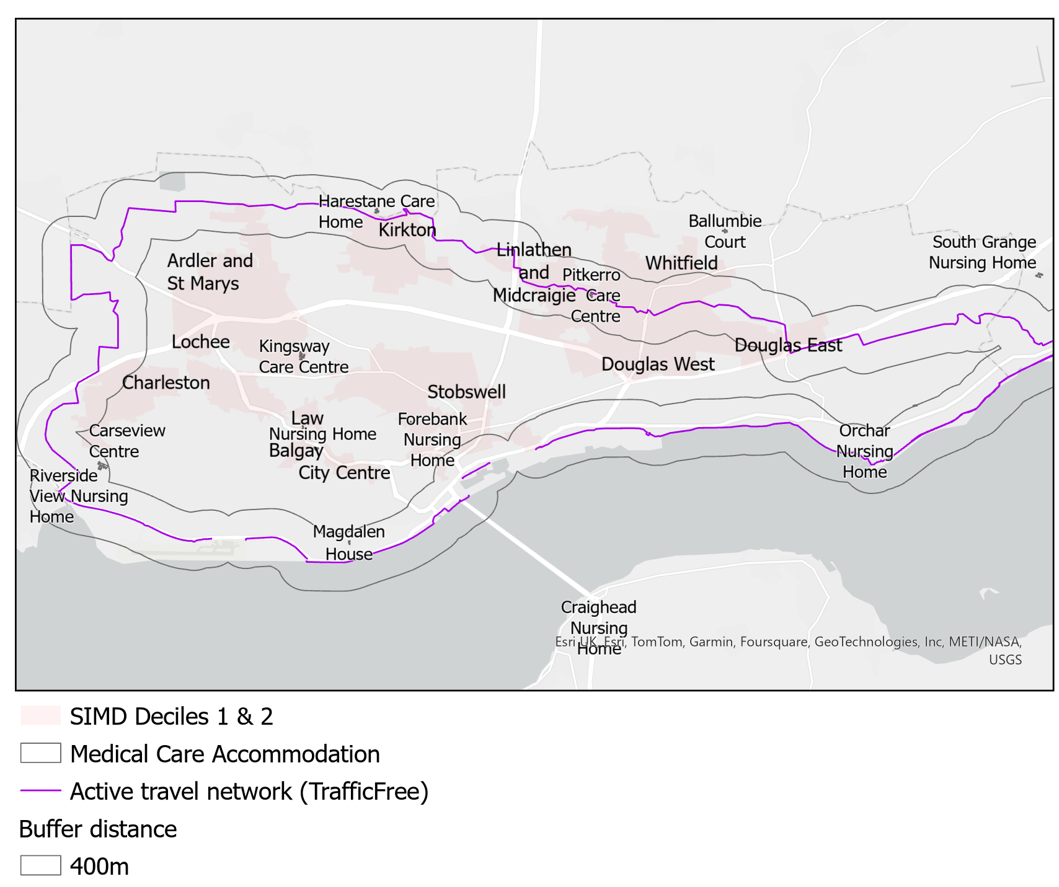
Figure 1: Cluster 3 Accessibility & Inclusion

Projects
Table 2 below outlines which projects are to be delivered within the cluster area, general budgets associated with each and the minimum number of schools and workplaces to be engaged with. The following information can be used to develop an EOI where appropriate.
Table 2: Cluster Project Details
Project | TS Theme | Description | Total cost (£) | Estimated minimum quantity
Urban trail design/active travel improvement audits  (Ref 3.1) | Accessibility & Inclusion | Active Travel Trails (Trails) are signposted, themed routes within an urban setting to enable more everyday walking, wheeling and cycling journeys on peoples’ doorsteps, so physical activity and social interaction can integrate better with their everyday life. Work could include minor improvements to improve function existing routes, connecting key facilities and making trips more comfortable for all and creating routes to be more inspiring, evoking curiosity. | 150,000  (Capital and revenue) | 1 or multiple trails
Access to bikes within schools  (Ref 3.2) | Schools & Young People | Not all young people have access to bikes – it can be a major financial burden for parents/carers given how fast children grow out of them. Availability of free, recycled bikes helps overcome this, providing children with greater freedom and improved transport connectivity. | 52,000  (Mostly capital plus management costs) | Approx. 10 schools
Access to bikes: Dundee Cycle Hub, workplaces, and disadvantaged groups  (Ref 3.3) | Workplaces, Accessibility & Inclusion | Provision of access to free bikes / low cost leased bikes within workplaces (including universities and other further education establishments). Workplaces on existing or newly proposed routes can be targets of schemes that look to maximise the benefits of these. | 115,000  (Mostly capital plus management costs) | Workplaces located around the NCN and Dundee Cycle Hub in Dundee. Total of 5 neighbourhoods within top 20% most deprived.
Active Travel promotion within schools  (Ref 3.4) | Schools & Young People | Education and awareness campaigns on the benefits of active school travel, with incentivisation schemes to encourage uptake. | 85,000  (Mostly revenue) | Approx. 10 schools
Engagement with schools (including parents/carers) on active travel  (Ref 3.5) | Schools & Young People | Engagement with students and parents/carers to identify ways of improving opportunities for active school travel (Such as School Streets/Play Streets and walking/cycling buses). | 15,000  (Mostly revenue) | Focus to be on priority primary schools
Engagement and travel planning with communities and workplaces  (Ref 3.6) | Workplaces | Workplace engagement, awareness campaigns and use of behaviour change technology to encourage people to consider active travel as a viable option for their commute. The programme of works would ensure that workplaces that have the resources available to them are made self-sufficient to continue delivery themselves, this is something that Tactran can monitor with delivery partners as cluster areas change. | 70,000  (Mostly revenue) | Workplaces located around the NCN and Dundee Cycle Hub in Dundee. Total of 5 neighbourhoods within top 20% most deprived.
Confidence building and cycle training for adults  (Ref 3.7) | Workplaces, Accessibility & Inclusion | Sessions where employees or those from disadvantages backgrounds are taught the necessary skills to cycle safely on the road and carry out basic bike maintenance. | 50,000  (Mostly revenue) | Approx. 15 locations/community groups
Cluster 3 Total |  |  | £537,000

Monitoring and Evaluation
It is expected that all projects will include appropriate monitoring and evaluation in line with the outcomes in table below. Costs for monitoring should therefore be included within the budget for each project. Specific monitoring and evaluation requirements will be discussed further following the EoI process. The outcomes are based on those identified in the Active Travel Framework and form part of Transport Scotland’s Monitoring and Evaluation framework which is under development.
Project | Active Travel Framework Outcomes
Local trail design/active travel improvement audits. | - Identifying and overcoming barriers to active travel can increase in the number of people choosing walking, wheeling and cycling in Scotland, and in particular, making these modes available to all.  - Identifying and developing local trails will ensure high quality walking, wheeling and cycling infrastructure is available to all.
Access to bikes within schools | - Providing children with bikes helps make cycling available to all. This can raise enthusiasm levels amongst young people and directly contribute to an increase the number of people choosing cycling in Scotland, both in the short and long term.
Access to bikes: workplaces, communities and disadvantaged groups | - Providing access to bikes within workplaces can reduce the barriers to active travel, and helps with making cycling available to all, increasing household access to a bike and decreasing the proportion of people identifying barriers to cycling.  - Free / low-cost bike provision can help increase the number of people choosing cycling in Scotland.
Active Travel promotion within schools | - Promotion of active travel in schools can lead to an increase the number of people choosing walking, wheeling and cycling in Scotland.  - Delivery of walking, wheeling and cycling is promoted and supported by a range of partners – where active travel groups, local stakeholders and parents can collaborate to identify key future initiatives or discuss concerns.
Engagement with schools (including parents/carers) on active travel | - Fostering an understanding of local active travel facilities and opportunities within the community can lead to an increase the number of people choosing walking, wheeling and cycling in Scotland.  - Delivery of walking, wheeling and cycling is promoted and supported by a range of partners – where active travel groups, local stakeholders and parents/carers can collaborate to identify key future initiatives or discuss concerns.
Engagement and travel planning with communities and workplaces | - Increase the number of people choosing walking, wheeling and cycling in Scotland, and can also shift attitudes towards/propensity to walking, wheeling and cycling.  - Reduce the proportion of people identifying barriers to walking, wheeling and cycling.
Confidence building and cycle training for adults | - Providing cycle training to adults who are less confident on the road can overcome barriers around perceptions of safety of cycling – therefore making cycling available, and safer, to all, and improving attitudes towards / propensity to cycling.

EoI Process

Required Information
The EoI form asks for the following, please find this attached in Appendix A:
- Organisation details and contact details
- Project the EoI relates to (one form per project)
- Details of the project you wish to run:
  - Brief summary of experience
  - Proposed project summary
  - Proposed objectives
  - Proposed outcomes
  - Estimated costs broken into Capital, Revenue and cost of Monitoring and Evaluation
  - Proposed resource
- Monitoring and evaluation plan

Review Process
Once submitted your EoI will be reviewed by members of the Tactran team, who will provide feedback and may request a further discussion on the following:
- Project fit to the overall cluster plan.
- The project cost proportionate to its proposed impact, and its fit within the overall budget.
- The suitability of the resource to deliver in the area outlined.
- How the project fits in with other EoIs and projects that will be delivered by local authorities
- The suitability of the project objectives and outcomes to support the regional delivery plan.
To help gather feedback on your submission, we may share it with relevant local authorities.

Timescales
Key dates are as follows:
Activity | Date
Invitation issued | 28/02/2024
Closing date for responses | 13/03/2024
Feedback/further discussions to begin | 20/03/2024

How to submit
Completed forms in Appendix A should be emailed to info@tactran.gov.uk by 5pm on 13th March 2024.

Terms & Conditions
- Grants cannot be used to enable compliance with the conditions of planning permission or legal agreements.
- Applications are particularly welcome from groups working together but a nominated person from an eligible organisation must sign the application form on behalf of a lead organisation accepting the conditions of the grant.
- The grant may be used to pay for the pre-construction, construction or post-construction element of a capital active travel project as outlined in the application form, which demonstrates potential benefits to the region by achieving the objectives of this grant scheme.
- Applicants must ensure best value where procurement legislation is not applicable. Relevant evidence needs to be kept for a period of seven years.
- The application must supply adequate information to justify the scheme. This should include the potential benefit of the scheme and how the actual benefit will be measured.
- This grant is awarded for the specific purposes outlined in your application. Tactran reserves the right to recover some or all of the funding if not used for the purposes intended.
- The applicant will be solely responsible for payment to contractors and partners and any overrun of costs - Tactran and its constituent bodies cannot be held responsible for such eventualities.
- Grants are not mandatory and will be offered solely at the discretion of Tactran.
- Applicants should not make financial commitments relating to this grant funding until the offer of a grant is accepted in writing.
- Successful applicants will ensure acknowledgement of the Tactran Active Travel Behaviour Change and Access to Bikes Grant is evident in all work relating to the scheme, clearly identifying the funding through the Tactran Active Travel Behaviour Change and Access to Bikes Grant and by stating “funded by Tactran and Transport Scotland.
- Tactran may use a successful applicant’s scheme to promote the Tactran Active Travel Behaviour Change and Access to Bikes Grant and wider Tactran objectives.
- Any data collected can be requested and processed by Tactran and its affiliated partners.
- Quarterly reports are required, reflecting the target outcomes and Key Performance Indicators.
- End of project: A brief final report must be provided once the scheme is implemented including monitoring and evaluation results.
Tactran will reserve the right to request evidence such as copies of signed (and preferably audited) financial statements, evidence of good financial management (diverse funding streams, contingency plans), good budgetary monitoring (regular reconciliation of actual versus budgeted expenditure, clear identification of separate funding streams), effective internal controls (internal audit functions), and clear policies and procedures on fraud, bribery and corruption.
Fair Work First
All Sottish Government grants awarded from 1 July 2023 must include Fair Work First conditionality requiring grant recipients to pay at least the real Living Wage, and provide appropriate channels for effective workers’ voice, such as trade union recognition. This conditionality applies to:
- all directly employed staff of the grant recipient,
- any workers who are not directly employed but are directly engaged in delivering the grant-funded activity, whether they be sub-contractors or agency staff.
Real Living Wage
- In general, a grant recipient must demonstrate it is paying the Real Living Wage before it can access a grant;
- all directly employed staff of the grant recipient must be paid at least the Real Living Wage and any workers who are not directly employed but are directly engaged in delivering the grant-funded activity, whether they be sub-contractors or agency staff, must also be paid at least the Real Living Wage (including Apprentices);
As evidence we may require either Living Wage Accreditation; or Anonymised payroll; or Accountant certificate.
Effective workers’ voice
- All organisations with a workforce must be able to demonstrate before they can access a grant that all workers employed within that organisation have an effective voice;
- voice exists at both collective and individual levels and organisations will be expected to show how genuine and effective voice is evidenced;
The collective element of voice does not have to be evidenced by organisations with fewer than 21 workers.
Guidance on the types of evidence you should provide (e.g. Written confirmation from trade union/worker representative of things like effective Line Management Relationships, Staff /Engagement Surveys, Staff Forums / Networks etc) are here: https://www.gov.scot/publications/fair-work-first-guidance-2/pages/11/.
Work with vulnerable people
It is important we have assurances relating to the safeguarding of vulnerable groups. If your programme involves working with vulnerable groups, please confirm that you have:
Robust safeguarding policies and procedures in place to protect vulnerable adults and children (these may include things such as a specific safeguarding policy, training, support and supervision of staff, a Code of Conduct).
A whistleblowing and monitoring and complaints processes.
A clear procedure which must be followed if you become aware of any specific safeguarding incident.
And that you will seek similar assurances on these points from onward grant recipients.

Appendix A
Expression of Interest (EoI) Form

Cluster 3 – Dundee/Angus
Organisation name and address:
Key contact name:
Key contact:
Email
Phone number
Project area EoI relates to: | ☐ Urban trail design/active travel improvement audits (Ref 3.1)  ☐ Access to bikes within schools (Ref 3.2)  ☐ Access to bikes: Dundee Cycle Hub, workplaces, and disadvantaged groups (Ref 3.3)  ☐ Active Travel promotion within schools (Ref 3.4)  ☐ Engagement with schools (including parents/carers) on active travel (Ref 3.5)  ☐ Engagement and travel planning with communities and workplaces (Ref 3.6)  ☐ Confidence building and cycle training for adults (Ref 3.7)
Project title (Ref No.) and Brief summary of relevant experience (include reference to similar work undertaken previously, existing work / relationships in cluster area):
Proposed Project Summary (max 200 words)
Project objectives (max 5)
Project outcomes (max 5)
Estimated costs for project delivery (including any breakdown of Capital and Revenue Funding): | Total Cost £  Of which Capital £  Of which Revenue £  Of which M&E £
Overview of resource availability (i.e. number of staff members and location) to meet project aims:
Proposed monitoring and evaluation activities to measure deliverability against outcomes (see Section 4):
Does your organisation pay staff the Real Living Wage? | Yes ☐ No ☐
If you responded ‘No’ above, please provide detail as to why:

