Tactran RTS Targets: baseline and options
Document no: 1
Version: Draft v2

Tactran RTS Targets
23 May 2023

Tactran RTS Targets: baseline and options
Client name: | Tactran
Project name: | Tactran RTS Targets
 |  | Project no: | B2340238
Document no: | 1 | Project manager: | Caley McDowall
Version: | Draft v2 | Prepared by: | Tim Steiner
Date: | 23 May 2023 | File name: | Document1
Document history and status
Version | Date | Description | Author | Checked | Reviewed | Approved
1 | 1/5/23 | Interim draft for discussion | TJS
2 | 23/5/23 | Updated interim draft | TJS
Distribution of copies
Version | Issue approved | Date issued | Issued to | Comments
Jacobs U.K. Limited
160 Dundee Street  Edinburgh, EH11 1DQ  United Kingdom | T +44 (0)131 659 1500  F +44 (0)131 228 6177  www.jacobs.com
Copyright Jacobs U.K. Limited © 2023.
All rights reserved. The concepts and information contained in this document are the property of the Jacobs group of companies (“Jacobs Group”). Use or copying of this document in whole or in part without the written permission of Jacobs Group constitutes an infringement of copyright. Jacobs, the Jacobs logo, and all other Jacobs Group trademarks are the property of Jacobs Group.
NOTICE: This document has been prepared exclusively for the use and benefit of Jacobs Group client. Jacobs Group accepts no liability or responsibility for any use or reliance upon this document by any third party.

Contents
1. Introduction 1
2. Increase sustainable mode share 2
3. Physical activity in more deprived communities 6
4. Improve accessibility 11
5. Journey time reliability 12
6. Reduce emissions 16

Appendices
Appendix A. Forecast traffic flow as proportion of capacity 19

Introduction
This note sets out interim findings of Jacobs’ work for Tactran to investigate the potential for targets to inform the emerging new RTS.
For each of the indicators which Tactran is considering, this note sets out summary information on:
- Baseline data;
- Relevant extant targets;
- What could be achievable by 2033 (the timescales for the RTS);
- Costs of delivery;
- Implementability.
The information is intended to enable Tactran to consider what level of change is appropriate to set as a target for each of these indicators.
All of the content of this interim note is provided as the basis for discussion only; key discussion points and uncertainties are highlighted in bold.

Increase sustainable mode share
Draft target | 1.2.2 Increase the share of trips made by sustainable modes such as walking, cycling and public transport
Baseline data | The extant data on mode share in the region is limited.  Extrapolation of Scottish Household Survey Travel Diary Survey data and market research on travel patterns recently undertaken by Tactran suggests the following modal shares and that the total number of journeys made varies as shown:  Regional average Perth & Kinross Council Dundee City Council Angus Council Stirling Council  Walking 22% 25% 28% 27% 20%  Driver car/van 53% 51% 43% 57% 56%  Passenger car/van 13% 12% 13% 7% 12%  Bicycle 1% 1% 2% 1% 1%  Bus 7% 6% 9% 5% 7%  Taxi/ minicab 1% 1% 2% 1% 1%  Rail 2% 2% 3% 1% 3%  Other 1% 1% 1% 1% 1%  Relative number of journeys made per person 100 117 99 91 102  Note that the mode share of distance travelled is very different:
Extant targets | The Scottish Government has set a target to reduce car-km by 20%, in comparison with a 2019 baseline, by 2030, but this is not accompanied by a mode share target.  Local authorities have set some relevant targets:  - Stirling LTS : Car modal share to decrease by 10% compared to 2017 levels; Proportion of people accessing Stirling City Centre on foot: 10% increase compared to 2017 levels; % increase of annual average daily total of cyclists on monitored routes: 50% increase compared to 2017 levels;  - Perth’s Transport Future: One of the strategic objectives is to increase the proportion of short trips by more sustainable modes setting out targets to achieve a: 5% increase in cycling; 20% increase in walking; 20% increase in Park and Ride.
What could be achieved by 2033 | Outcomes are considered to be highly variable, depending on the types of measures which are adopted to influence mode share, as the total number of journeys made is not fixed.  For example, the 20% car-km research for Tactran showed that:  - Doubling the number of public transport journeys would reduce car-km by only about 4% (and that only a maximum of one quarter of this change could be delivered by 2030);  - Major improvements in active travel could increase regional walking mode share from 19% to 24% and cycling from 0.6% to 19%, but only 11% of new active journeys would switch from car and so car-km would fall by only around 3% (and that only a maximum of one quarter of this change could be delivered by 2030).  The data below suggests one method of defining potential mode share targets, based on the logic of achieving a 20% reduction in car use and then working to ensure there is no reduction in overall travel (which would imply that fewer people are accessing goods and services). There are other potential ways to construct logical targets, so discussion of this would be appreciated.  Extrapolation of the mode share data for the region presented above and the modal diversion factors provided by DfT’s WebTAG suggests that changes in use of car/taxi as a mode will result in trips transferring to/from other modes or being generated/suppressed as shown:  Change in use of car Will result in trips transferring to/ from  Public transport Active travel No travel  52% 34% 30%  Note that the data in the table above provides an indication of the number of journeys that would switch between modes, not a forecast of car-km.  If therefore the 20% car-km reduction target was met by a 20% reduction in the number of car journeys, then this analysis suggests that the proportion of journeys would change as shown:  Extant mode share (taken from table in extant data section above) Mode share following 20% reduction in car use Notes  Car (including van and taxi) 67% 53% 20% less than extant  Active travel (walking and cycling) 23% 27% Car trips to active travel and public transport trips redistributed according to the proportions outlined above  Public transport (bus, rail and ‘other’) 10% 16%  Total of journeys 100% 96% Fewer journeys now undertaken because of suppression of some trips  The analysis suggest that a 20% reduction in car use could result in a reduction in the total number of journeys travelled by around 4%.  It is anticipated that regional partners would seek to eliminate any such reduction, in order that there is no net detriment to people’s ability to access goods and services as a result of reduced car use.  If measures were put in place to encourage more active and public transport journeys to replace the 4% of journeys, and if these were spread equally between public transport and active travel (so raising the mode share of both public transport and active travel by two percentage points each), then resulting mode shares would be:  Extant mode share (taken from table above) Mode share following 20% reduction in car use and measures to encourage public transport and active travel  Car 67% 53%  Active travel 23% 29%  Public transport 10% 18%  Total of journeys 100% 100%
Potential business-as-usual outcome by 2033 | In a business-as-usual scenario, car use in the region is expected to increase, and the recent trend of declining public transport use (which was exacerbated by Covid) could continue. Modest increases in walking and more significant increases in cycling could be expected (see data on physical activity target below).  A challenging business-as-usual target is therefore to maintain mode share of use of car at no more than the extant level of 67%.
Costs of delivery | TBC, depending on measures  Would like to discuss this, as potentially many options to present
Implementability | The 20% car-km reduction commission identified the challenges of short-term implementation of measures to affect modal shift, demonstrating the financial, feasibility and public acceptability risks.  In summary, it identified that the measures seeking to improve sustainable transport choices are relatively easy to deliver, but highly costly, whereas those which restrain car use are typically affordable but face significant barriers for public acceptability.  It also identified that, whilst local and regional partners could significantly reduce car use by measures within their control, national leadership will be required for car-km targets to be met.

Physical activity in more deprived communities
Draft target | 2.5.1 Levels of walking and cycling in the lowest SIMD datazones (health domain)
Baseline data | The extant baseline of walking, wheeling and cycling in more deprived communities is not detailed/robust, and datasets are sometimes conflicting.  Active travel comprises around 20% of all minutes of physical activity.  Extrapolation of Scottish Household Survey Travel Diary Survey data and market research on travel patterns recently undertaken by Tactran suggests the following modal shares, and that people living in more deprived communities do walk and cycle proportionately at least as much as the regional average (though the average number of journeys made by them is lower):  Regional average SIMD 1&2 – Most deprived SIMD 3&4 SIMD 5&6 SIMD 7&8 SIMD 9&10 – Least deprived  Walking 22% 25% 25% 24% 20% 17%  Driver car/van 53% 41% 46% 51% 56% 65%  Passenger car/van 12% 13% 13% 12% 12% 10%  Bicycle 1% 2% 1% 1% 1% 1%  Bus 7% 12% 10% 7% 6% 3%  Taxi/ minicab 1% 2% 1% 1% 1% 1%  Rail 2% 4% 3% 2% 3% 2%  Other 1% 1% 1% 1% 1% 1%  Relative number of journeys made 100 81 91 102 107 111  However, almost all of the most health deprived communities in the region are in urban areas, where rates of active travel are higher than average, because of the typically shorter journey distance in towns and cities. When this is accounted for, there does appear therefore to be a correlation between deprivation and lower levels of walking and cycling.  Anecdotal evidence collected by Jacobs staff during extensive engagement in communities in the region suggests that, in more deprived communities:  - Low levels of income and typically short journeys distances force or enable many people that live in more deprived communities to undertake a high proportion of their journeys by active modes, especially on foot; but  - In more deprived communities, a higher proportion of people are unable to walk or cycle, so may be dependent on motorised modes if they are able to travel at all.
Extant targets | Chief Medical Officers’ physical activity targets, which are complex and different for different age groups, include for adults (19 to 64 years): “For good physical and mental health, adults should aim to be physically active every day. Each week, adults should accumulate at least 150 minutes (2 ½ hours) of moderate intensity activity (such as brisk walking or cycling); or 75 minutes of vigorous intensity activity (such as running); or even shorter durations of very vigorous intensity activity (such as sprinting or stair climbing); or a combination of moderate, vigorous and very vigorous intensity activity”.  Scotland’s Physical Activity Delivery Plan sets out a “target of achieving a 15% relative reduction in the global prevalence of physical inactivity in adults and in adolescents by 2030”.  Local authority active travel targets:  - Stirling LTS : Proportion of people accessing Stirling City Centre on foot: 10% increase compared to 2017 levels; % increase of annual average daily total of cyclists on monitored routes: 50% increase compared to 2017 levels;  - Angus ATS: For the proportion of Angus residents walking for utility journeys weekly or more often to be at least equal to the Scottish average by 2034; For the proportion of Angus residents cycling for utility journeys weekly or more often to be greater than 10% by 2034;  - Perth’s Transport Future: One of the strategic objectives is to Increase the proportion of short trips by more sustainable modes setting out targets to achieve a: 5% increase in cycling; 20% increase in walking;  - PKC ATS: Perth & Kinross Council and its partners will seek to: Increase the number of journeys made on foot across Perth and Kinross as recorded in the 2011 Census for Scotland; Increase the number of journeys made by bike in Perth and Kinross as recorded in 2011 Census for Scotland; Increase the proportion of residents of Perth and Kinross walking more than 30 minutes in one go per month by 5% by 2028 in comparison with a 2018 baseline; Increase the proportion of residents cycling monthly or more often in Perth and Kinross by 50% by 2028 in comparison with a 2018 baseline;  - Dundee Cycling Strategy : Dundee City Council and its partners will aim: To increase the number of journeys made by bike annually in Dundee by 200% by 2026 in comparison with the 2016 baseline, with an interim target of 100% by 2021; To increase the number of Dundee residents cycling monthly or more often by 100% by 2026 in comparison with the 2016 baseline, with an interim target of 50% by 2021; For the number of cyclist casualties in road crashes in Dundee, as reported by Police Scotland data, to be no higher in any year than the 2010-14 average; and To increase the number of children who cycle to school by 100% by 2021 in comparison with the 2014 baseline data.
What could be achieved by 2033 | STPR2 made forecasts (by local authority and urban/rural classification, not specifically by health or community deprivation level) of what could be achieved by long-term, comprehensive investment in high-quality active travel facilities. These are listed below, but are valid only if “all the active travel and behaviour change interventions were fully implemented in every relevant location in the region”, and hence are not indicative of what is deliverable by 2033.  Local Authority Average proportion of all journeys walked  Baseline Forecast with STPR2 active travel groupings  Angus 17% 22%  Dundee City 24% 30%  Perth and Kinross 17% 20%  Stirling 17% 21%  Regional average 19% 23%  Local Authority Average proportion of all journeys cycled  Baseline Forecast with STPR2 active travel groupings  Angus 0.7% 19%  Dundee City 0.7% 23%  Perth and Kinross 0.5% 15%  Stirling 0.5% 18%  Regional average 0.6% 19%  Urban-rural 6-fold classification Average proportion of all journeys walked  Baseline Forecast with STPR2 active travel groupings  Large Urban Areas 24% 30%  Other Urban Areas 19% 24%  Accessible Small Towns 20% 26%  Remote Small Towns 24% 31%  Accessible Rural 12% 14%  Remote Rural 15% 16%  Scotland total 19.9% 24.9%  Urban-rural 6-fold classification Average proportion of all journeys cycled  Baseline Forecast with STPR2 active travel groupings  Large Urban Areas 1.5% 24%  Other Urban Areas 0.4% 19%  Accessible Small Towns 0.5% 13%  Remote Small Towns 0.7% 11%  Very Remote Small Town 0.7% 10%  Accessible Rural 0.4% 7%  Remote Rural 1.0% 7%  Very Remote Rural 0.5% 4%  Scotland total 1.4% 19.1%  Impacts on more deprived communities would depend on local and regional decisions about where investment in the region is targeted, but it is reasonable to assume that the proportional rates of increase in walking and cycling indicated in the tables above could be achieved; i.e. that investment could increase the amount of walking by around 25% (= (24.9% / 19.9%) – 1) and cycling by 1300% (= (19.1% / 1.4%) – 1).
Potential business-as-usual outcome by 2033 | The Scottish Government has committed to invest £320M per annum on active travel. If 9% of this came to the Tactran region (based on the population data outlined in the ‘costs of delivery’ section below), then potential investment of £29M per annum may be possible in the region.  If this came fully on stream by 2027 (reflecting the requirement for Local Authorities and other partners to build capacity for implementation and currently-observed challenges in scheme development nationally), then it might be reasonable to assume that a total of around £175M (~ £29M x 6) could be invested within the timescales of the RTS, around one eighth to one quarter of the potential long-term region-wide investment requirement of £700-1,400M (see ‘costs of delivery’ section below).  At present there is no clear indication that Local Authorities are specifically targeting active travel investment at deprived communities, so it is assumed that likely business-as-usual increases in active travel rates in deprived communities by 2033 would be in the range of one eighth to one quarter of the increases shown in the tables above (i.e. the same as the regional average).  It could therefore be expected to increase the mode share of walking in the most deprived communities by approximately one percentage point (with the number of walking journeys increasing by 3-6%), and the mode share of cycling in the range of 2 to 4 percentage points (with the number of cycling journeys increasing between one- and three-fold).  Given that the baseline level of walking is relatively high but that for cycling low, this suggests only modest increases in the amount of walking in more deprived communities are to be anticipated, but significant proportional growth in cycling could be achieved (from its low base).  However, the change achieved will be highly dependent on the types and locations of the schemes to be implemented.
Costs of delivery | The investment required to achieve the active travel outcomes forecast by STPR2 across all of Scotland is in the range of £7-14bn.  Tactran’s regional population = 511k, 9% of Scotland total. Tactran’s region = 9,900 sqkm, 12.5% of Scotland total.  Hence if Tactran warrants ~10% of national total spend on active travel, then there is a budget requirement of £700-1,400M required to deliver the high quality infrastructure throughout the region on which the forecasts above are based.  7% of the region’s datazones are in the most deprived quintile in Scotland. Delivering significantly increased rates of walking and cycling in these more deprived communities would, however, require investment in infrastructure not only within them but beyond, both to ensure connections are made from those communities to all relevant destinations and also to support a change in travel behaviours throughout the population.  If it assumed that delivering significant active travel increases in the most deprived communities requires investment in one quarter of the region (to account for improvements within the priority datazones and on routes connecting them to key destinations), then net investment in the region of £200-400M would be expected to be needed (i.e. around one quarter of £700-1,400M).
Implementability | Active travel improvement measures are largely feasible and typically enjoy public support. Almost all are within the control of local and regional partners.  The high cost of measures in comparison with currently available funding, the long implementation timescales that are typically observed for active travel infrastructure delivery in Scotland and the lack of capacity for large-scale delivery in the region significantly hamper what is likely to be achievable in terms of increasing active travel by 2033.

Improve accessibility in more deprived communities
Draft target | 3.1.2 Improve ability of all in the lowest SIMD datazones (all domains) targeted by the respective Council to access jobs, education and services  3.1.2b Ability of all in the lowest SIMD datazones (health domain) targeted by the respective Council to access healthcare
Baseline data | Jacobs is working to update the baseline accessibility indices.

Journey time reliability
Draft target | 4.1.1 Improve journey times and journey time reliability on strategic road and rail routes for public transport to key destinations  4.1.2 Improve journey time reliability for freight to key destinations
Baseline data | TCRTM data being extracted – will be included in updated version of this note
Extant targets
What could be achieved by 2033
Costs of delivery
Implementability

Reduce carbon emissions
Draft target | 1.1.2 Reduce estimated CO2 emissions from transport in the region.
Baseline data | It is estimated that transport is responsible for 35.6% of carbon emissions in Scotland.  Net emissions of greenhouse gases by transport allocated to Scotland were 13.9 MtCO₂e in 2019, of which 66% was from road transport, and 14% from international aviation/shipping.  The source of transport emissions are as shown in the graph:  According to Scottish Government data, carbon emissions from transport has fallen by only 6.7% in the period from 1990 to 2019 (total emissions fell by 43.8%).  Moreover, transport emissions were no lower in 2019 than 2015:  Year Carbon emissions from transport (MtCO2e) Annual emissions as proportion of 1990 total  1990 14.9 100%  2015 13.8 93%  2016 14.2 95%  2017 14.5 97%  2018 14.3 96%  2019 13.9 93%  The average age of the car/van fleet in Scotland in 2020 was 7.6 years, hence there is the expectation that around half of the vehicle fleet will be replaced by 2030.  In 2020, around 6% of the new cars sold in Scotland were fully electric; this is a substantial increase on historic proportions, but ULEVs still made up only around 0.5% of all cars in Scotland in that year.
Extant targets | The Climate Change Plan Update requires the transport sector to reduce emissions by 56% by 2030 on the 1990 baseline, to 6.5 MtCO₂e – but this includes aviation and maritime, modes largely outwith the influence of the RTS.  A summary of the emissions reduction effort across sectors (relative to 2018) in Policy Scenario 3 is shown below:  Sector Emissions saving by 2030 (%) Emissions saving by 2040 (%) Emissions saving by 2045 (%)  Car 78% 98% 100%  Bus and Coach 79% 96% 100%  Rail 42% 100% 100%  Vans 47% 95% 100%  Trucks 52% 89% 100%  Local Authorities’ Carbon Aspirations  Angus Council  - AC declared a climate emergency in September 2019  - AC do not have their own specific carbon reduction targets, but are working towards the Scottish Government’s targets  - AC’s Sustainable Energy and Climate Action Plan was approved in November 2021. The plan comprises seven key sectors: Buildings, Energy, Transport, Land Use & Forestry, Agriculture & Food, Waste, and Governance & Process, but does not contain any specific targets  Dundee City Council  - DCC declared a Climate Emergency in June 2019  - A partnership Climate Action Plan was published in 2019 which commits to surpass the Covenant of Mayors target of 40% reduction in greenhouse gas emissions by 2030 and achieve net-zero greenhouse gas emissions by 2045 or sooner, in line with the proposed targets of the Scottish Climate Change Bill  - Two performance indicators will be used to measure emissions reduction progress against the target: total carbon dioxide equivalent (CO2e) emissions (total and by end-use) in Dundee, and per capita (person) CO2e emissions in Dundee  - The plan comprises four key themes, each of which contains a number of actions and targets: Energy, Transport, Waste and Resilience  - Transport accounted for 25% of total CO2 emissions in Dundee in 2015  - The key objective for transport is to “encourage active travel through walking, cycling and public transport and deploy sustainable alternatives to decarbonise transport”  Stirling Council  - SC declared a climate emergency in October 2019  - SC’s Climate and Nature Emergency Plan (2021-2045) has two targets: Stirling Council will be carbon neutral in its own operations by 2035, and the Stirling Council area will achieve 'net zero' carbon by 2045  - The plan comprises five sectors, each with its own main objective: Energy Use & Generation, Transport, Resource Efficiency, Nature & Biodiversity, and Climate Adaption  - The main transport objective is to “develop a modern transport system that minimises carbon emissions, improves affordability, and provides choice for all”  - There are four priorities that sit within the transport objective:  - Make every trip in the Stirling area net-zero carbon  - Make walking and cycling easy, safe, and attractive travel options  - Help enable an effective, affordable public transport network  - Maximise sustainable choices for all  - The plan sets out the following transport performance indicators and interim and 2045 targets (^ indicates NTS2 targets and * indicates targets from the Climate Change Act)  Indicator (against a 2019 baseline) Interim target 2045 target  Area-wide targets  % reduction in carbon emissions from road traffic in the city area (1,608 tCO2 a year across monitored AADT routes) More than 40% by 2032^ 75%^  % of city centre journeys by active travel (against modal cordon count of 15.4%) At least 20% by 2030^ Increase of 30%^  % of Ultra Low Emission Vehicles (2.2% of all vehicles registered in Stirling in 2019) 45% by 2032 100%  % patronage increase in public transport (2.3m boarding 2019-20) 25% by 2030 50%  % reduction in carbon emissions from public transport (3,842 tCO2 in 2019-20) 25% in 2030 75%  Council targets  % of Stirling licensed taxis which are EVs (0% in 2019) 100% of new licenses by 2032 100% of all taxis operating in the area to be EV  % Council vehicle fleet running on ‘clean’ energy (3.1% in 2019) Phase out new petrol and diesel light commercial vehicles by 2025* 100% of all fleet clean by 2030*  % reduction in carbon emissions from Council business travel (4,450 tCO2 in 2006/07 baseline year) 45% by 2030 90%  Perth and Kinross Council  - P&KC declared their support for the Scottish Government and UK Parliaments’ climate emergency statements in 2019  - Climate Change Strategy and Action Plan was adopted by P&KC in December 2021 and commits to achieving Net Zero in line with the Paris Agreement and the Scottish Government Targets by 2045, with the ambition of achieving them sooner  - Transport emissions account for 52% of total CO2 emissions across Perth and Kinross, with cars providing 45% of these emissions, LGVs and HGVs providing 23% each, and trains providing the remaining 9%  - The plan comprises eight key areas: Transport, Buildings & Energy, Business & Industry, Waste & Circular Economy, Land Use, Climate Resilience, Education & Engagement, and Governance, but does not contain any specific targets:
What could be achieved by 2033 | It can be assumed that the Scottish Government consider that their targets for carbon reduction from transport (as set out under ‘Extant Targets’ above) are achievable. The Tactran region displays broadly similar characteristics in terms of overall population density and settlement patterns to the Scottish average, hence it could be assumed that the national targets are achievable in the region.  Emissions reductions from rail in the region may be able to exceed the national targets, as the Rail Decarbonisation Action Plan suggests that all rail lines in the Tactran region are to be electrified by 2030.
Potential business-as-usual outcome by 2033 | Emissions from cars are anticipated to be reduced in part by the 20% reduction in car-km, but to a greater extent by technological changes:  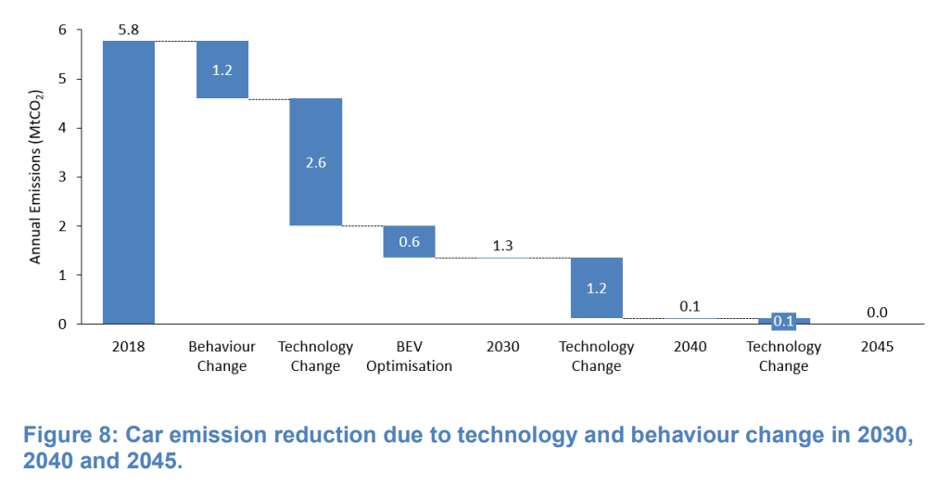  However, as work for Tactran to investigate the 20% car-km target has demonstrated, that target is achievable by 2030 but only with significant increases in both political will and funding. Without these changes, that work concluded that, without action, car-km in the region would be 10-15% greater in 2030 than 2019, and that business-as-usual action might reduce this by only around 1.5%; hence a net increase of 8.5-13.5%.  The availability and affordability of technological changes also cannot be guaranteed. The achievement of the carbon target assumes that 73% of cars operating in Scotland in 2030 will be ULEV, up from the 0.5% of 2020, despite the current average age of the fleet being longer than the period to achievement of the target.  17% of cars sold in the UK in 2022 were electric. Even if this proportion doubled to one third of all cars by 2024 and was sustained for the rest of the decade, then only around 23% of the total fleet would be ULEV by 2030 (if the current 17% proportion of new cars being electric was sustained throughout the decade , then only around 13% of all cars would be ULEV by 2030).  Some reductions in emissions per km from the non-ULEV fleet would also be expected (with new cars being less polluting than older ones), but net reductions of emissions per car-km are not expected to exceed around 30%.  Total net carbon emissions from car, therefore, are expected to fall in a business-as-usual scenario, but not by more than around 35% (~ 1.085% to 1.135% x 30%), and potentially less if the take up of ULEVs is lower than assumed here.  If, however, this reduction in emissions from car was achieved, rail in the region was fully decarbonised and bus and commercial vehicle fleets met their national targets for reduction in line with the Decarbonising the Scottish Transport Sector report, then net potential emissions reductions by 2030 could be:  Sector 2019 emissions (MtCO2e) Potential reduction by 2030 2030 emissions (MtCO2e)  Car 5.28 30% (from calculations above) 3.70  Bus and Coach 0.43 79% (assuming national target achieved) 0.09  Rail 0.15 100% (assuming rail is decarbonised as planned) 0.00  Vans 1.71 47% (assuming national target achieved) 0.90  Trucks 1.72 52% (assuming national target achieved) 0.83  Totals 9.29 5.52  This is considered to be a ‘best case’ scenario (as achieving all the targeted reductions from public and freight transport will be challenging), then emissions in 2030 will be 59% of those in 2019 (equivalent to 55% of the 1990 baseline emissions level).
Costs of delivery | The costs of decarbonising the rail network and of improving alternatives to car use are very high, and will fall largely to the public sector.  The costs of technological change to reduce fleet emissions are also high, but will be incurred largely by vehicle owners/operators. It is anticipated, however, that accelerating the uptake of ULEVs to or beyond the levels assumed may require public sector support to those vehicle owners/operators.
Implementability | The public sector has a significant role in enabling, encouraging and legislating for change.  Leadership on driving technological change and some elements of traffic reduction are required at local, regional and national levels.

Forecast traffic flow as proportion of capacity
We have larger-scale plots of the key areas if helpful.

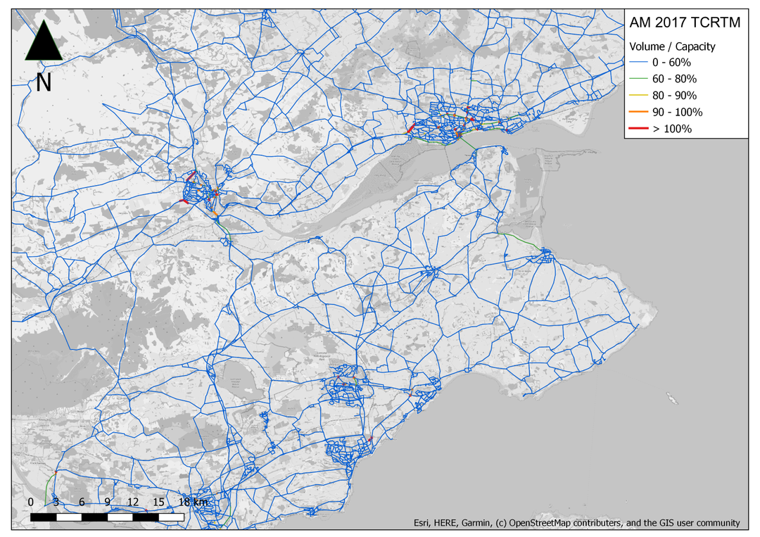
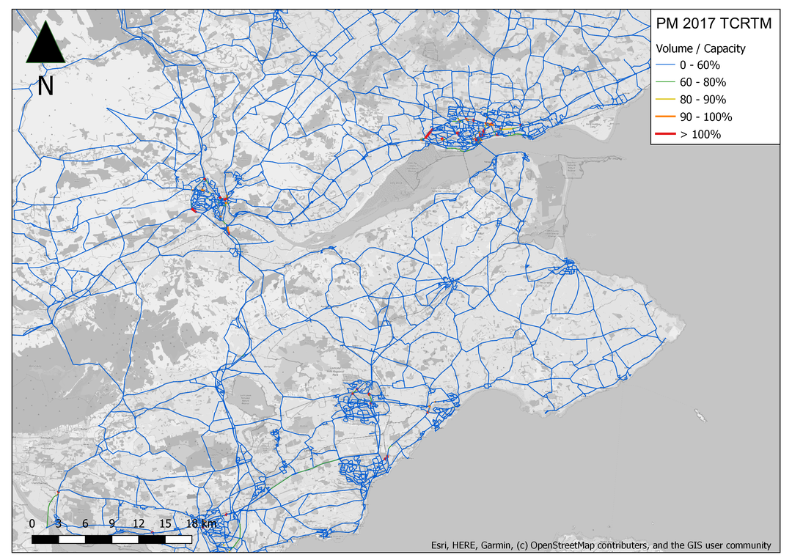
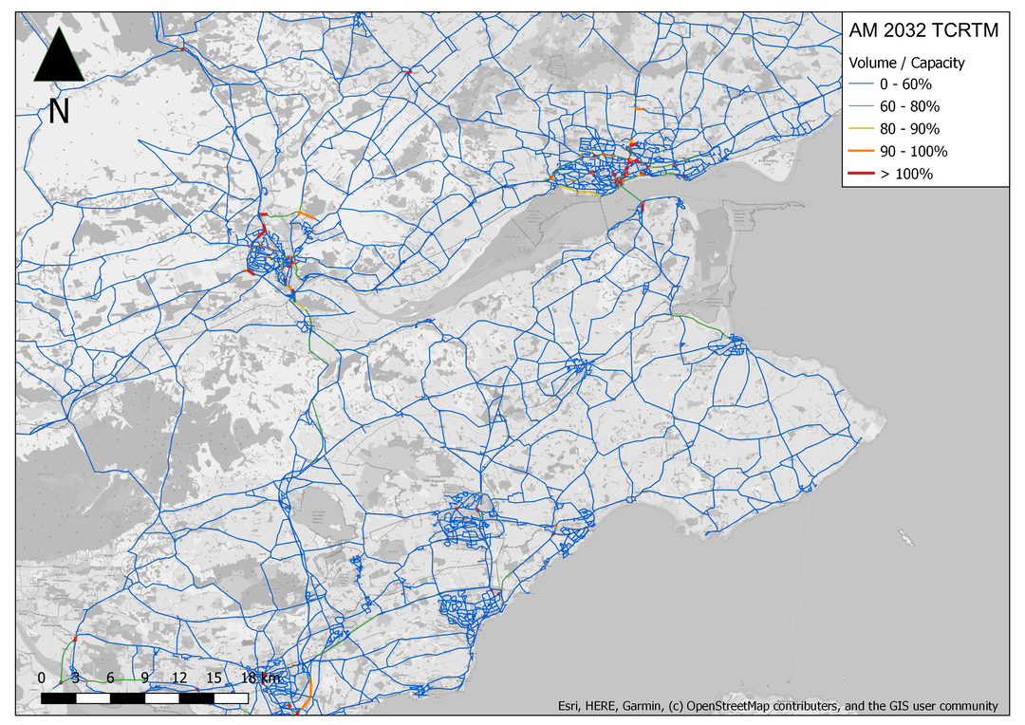
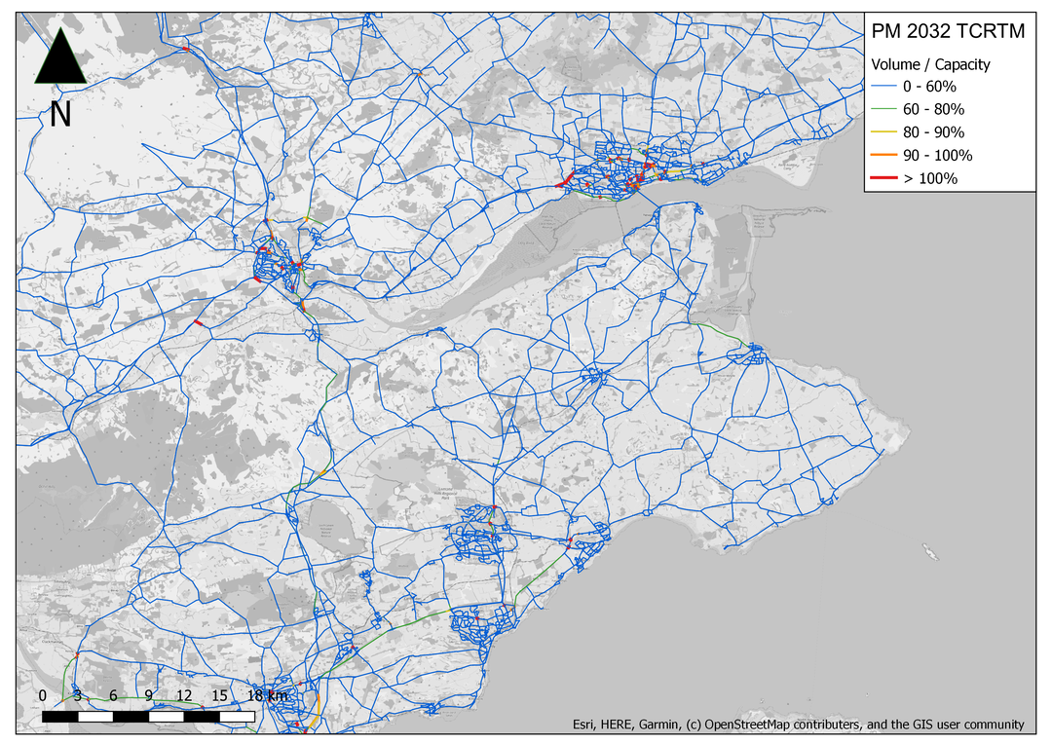

Local Transport Strategy
Local Transport Strategy
Active Travel Strategy
https://www.gov.scot/publications/scottish-greenhouse-gas-statistics-1990-2019/pages/8/
https://www.transport.gov.scot/publication/scottish-transport-statistics-2021/chapter-01-road-transport-vehicles/
https://www.transport.gov.scot/media/51312/chapter-13-environment-reference-tables-scottish-transport-statistics-2021.xlsx Tables 13.9 amd 13.10
https://europe.autonews.com/sales-market/evs-take-record-share-ailing-uk-auto-market-2022
Achieving a 20% Reduction in Car-km: Options for the Tactran Region
https://www.stirling.gov.uk/media/0jhnsaaz/local-transport-strategy-2017-2027.pdf
Achieving a 20% Reduction in Car-km: Options for the Tactran Region
https://www.gov.uk/government/news/active-travel-now-accounts-for-20-of-all-minutes-of-activity-taken-by-adults-in-england#:~:text=Cycling%20and%20walking-,Active%20travel%20now%20accounts%20for%2020%25%20of%20all%20minutes%20of,in%20the%20cost%20of%20living.
https://assets.publishing.service.gov.uk/government/uploads/system/uploads/attachment_data/file/832868/uk-chief-medical-officers-physical-activity-guidelines.pdf
https://www.gov.scot/binaries/content/documents/govscot/publications/strategy-plan/2018/07/active-scotland-delivery-plan/documents/00537494-pdf/00537494-pdf/govscot%3Adocument/00537494.pdf
https://www.stirling.gov.uk/media/0jhnsaaz/local-transport-strategy-2017-2027.pdf
https://perth-and-kinross.cmis.uk.com/Perth-and-Kinross/Document.ashx?czJKcaeAi5tUFL1DTL2UE4zNRBcoShgo=mZcCnujHqiTukOtjNVyedggYITs7XU2kYZGUKY9TX0HwyoLS84Z%2B1g%3D%3D&rUzwRPf%2BZ3zd4E7Ikn8Lyw%3D%3D=pwRE6AGJFLDNlh225F5QMaQWCtPHwdhUfCZ%2FLUQzgA2uL5jNRG4jdQ%3D%3D&mCTIbCubSFfXsDGW9IXnlg%3D%3D=hFflUdN3100%3D&kCx1AnS9%2FpWZQ40DXFvdEw%3D%3D=hFflUdN3100%3D&uJovDxwdjMPoYv%2BAJvYtyA%3D%3D=ctNJFf55vVA%3D&FgPlIEJYlotS%2BYGoBi5olA%3D%3D=NHdURQburHA%3D&d9Qjj0ag1Pd993jsyOJqFvmyB7X0CSQK=ctNJFf55vVA%3D&WGewmoAfeNR9xqBux0r1Q8Za60lavYmz=ctNJFf55vVA%3D&WGewmoAfeNQ16B2MHuCpMRKZMwaG1PaO=ctNJFf55vVA%3D
https://www.transport.gov.scot/media/50944/detailed-appraisal-summary-table-tay-cities-draft-technical-report-stpr2.pdf and https://www.transport.gov.scot/media/50936/detailed-appraisal-summary-table-forth-valley-draft-technical-report-stpr2.pdf
https://www.gov.scot/publications/securing-green-recovery-path-net-zero-update-climate-change-plan-20182032/
Scottish Transport Statistics 2021 https://www.transport.gov.scot/media/51312/chapter-13-environment-reference-tables-scottish-transport-statistics-2021.xlsx
https://www.gov.scot/publications/securing-green-recovery-path-net-zero-update-climate-change-plan-20182032/
https://www.transport.gov.scot/media/47906/rail-services-decarbonisation-action-plan.pdf
https://www.transport.gov.scot/media/50354/decarbonising-the-scottish-transport-sector-summary-report-september-2021.pdf

