Consultation on a new
Regional Transport Strategy 2023-2033
for the Angus, Dundee City, Perth and Kinross, and Stirling Council areas

A conversation about changing how we travel
Summer 2022
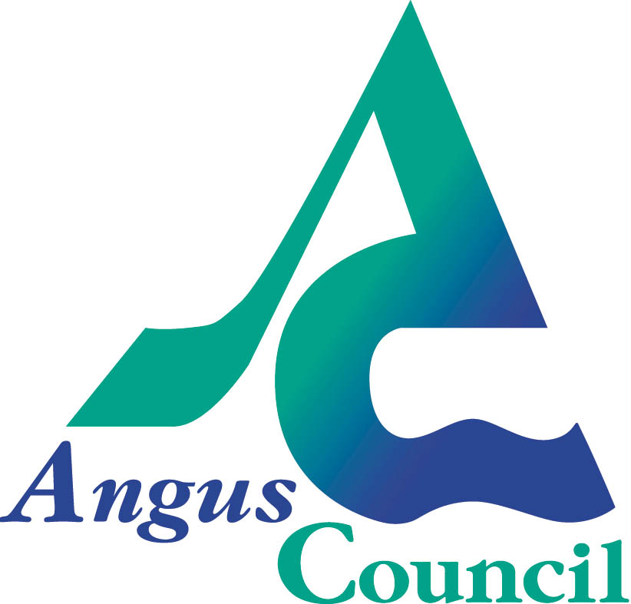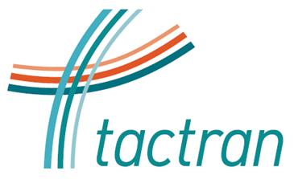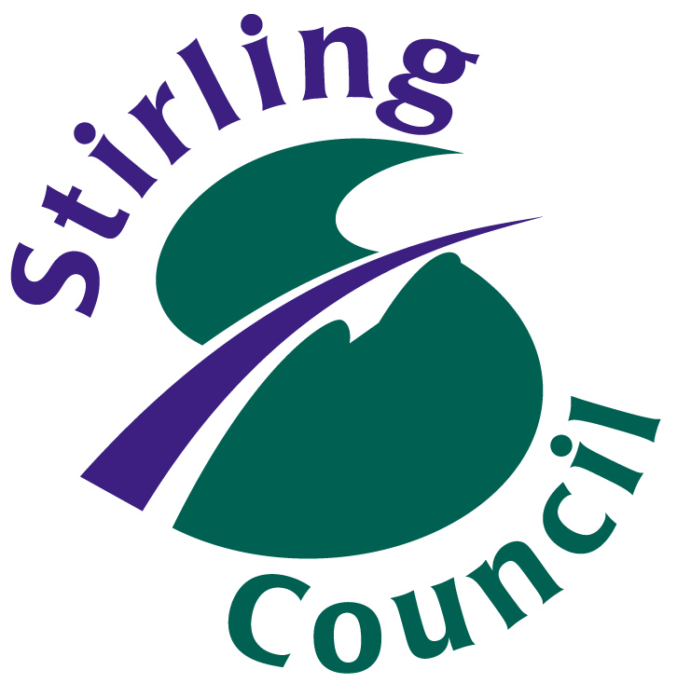
A conversation about changing how we travel

The Regional Transport Strategy 2023 – 2033 (RTS) produced by the Tayside and Central Scotland Regional Transport Partnership (Tactran) sets the strategic transport framework for Angus, Dundee, Perth and Kinross, and Stirling Councils. The RTS seek to combat climate change, social exclusion and promote healthy lives and sustainable and inclusive economic growth.
Given the climate change targets adopted by all four Councils in the Partnership, there is an urgency to changing how we travel. This will mean big changes for individuals, businesses as well as the Councils and others responsible for providing our transport systems.
We are therefore keen to understand what the implications of change will be for you, so that the strategy can provide an appropriate framework for change.
All partners in the Tactran partnership want:
- More, and affordable, public transport services
- A street environment which encourages people to walk and cycle when they can
- To reduce the amount we have to travel, either through on-line services, or providing services closer to home
However, delivering all this to achieve the climate change targets is likely to require authorities to review what is delivered where, when and how. It is also likely to require additional finances. Achieving this scale of change within the timescales set by the climate change targets will likely require measures that both discourage use of the car for those that have a choice, and also help finance alternatives. We want to know what the impact of such measures on you could be so that we can consider how they can be introduced in as fair and equitable manner as possible.
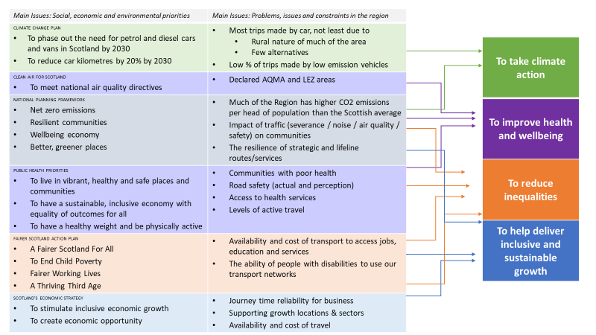
What does the RTS need to address?
Objectives
During Summer 2021 we sought your views on the issues that should shape the strategy. These issues then informed the draft objectives and outcomes for the strategy.
We now want to understand your views on:
- Draft objectives and outcomes
- The scale of change for individuals, businesses and delivery agencies (such as the Councils) required to hit national climate change targets
- Potential measures
This information will help us write a draft strategy, which we expect to consult on during 2023
Objectives and Outcomes
The table below identifies what we think we need to achieve (outcomes) to achieve the objectives
Q1: Do you agree with the objectives and outcomes?

Objectives | Outcomes
To take climate action | Reduce greenhouse gas emissions
 | Modal shift to more sustainable modes of travel
 | Reduce car mileage
 | Ensure our transport networks are resilient
To improve health and wellbeing | Reduce fatalities and injuries
 | Improve air quality
 | Improve ability for older people and disadvantaged communities to access healthcare
 | Improve ability for the most vulnerable to access social activities
 | Increase levels of physical activity
To reduce inequalities | Improve ability for young people, and disadvantaged & rural communities to access jobs, education and services
To help deliver inclusive and sustainable economic growth | Reliable inter and intra-regional journey times
 | Improve ability for young and disadvantaged communities to access jobs, education and training

The scale of the challenge
Just focusing on some of the outcomes proposed in table 1 highlights the scale of the challenge we have
Outcome | Aspiration | Scale of the challenge
Reduce greenhouse gas emissions  Reduce car mileage | The Climate Change Action Plan has set national targets to:  - reduce car km driven by 20% by 2030 | Reversing 29+ yrs of growth in car km in 8 years. Over ¾ of personal mileage are trips over 10km DfT Road Traffic Stats 2020
 | - phasing out need for new petrol or diesel cars or vans by 2030 | Less than 1% of personal vehicles registered in the Tactran region are electric Vehicle Licensing Stats 2022
Increase levels of physical activity  Improve air quality | Public Health Priorities for Scotland seek a Scotland where we….have a healthy weight and are physically active | 29% never walk as a means of transport, 30% never for pleasure SHS 2019
 | Air quality has exceeded national air quality thresholds in Dundee and Perth cities as well as Crieff | Our towns & cities serve large rural hinterlands. 60% of trips made by those living in the region are by car SHS 2019
Improve ability for young people, and disadvantaged & rural communities to access jobs, education and services | Child Poverty Act has set a target for the % of children living in Scottish households should be living in relative poverty to be reduced to 10% by 2030. | 20.6% of children in Angus, 22.5% in Dundee, 18.7% in Perth and Kinross and 18.1% in Stirling are living in relative poverty (2020/21)  Limited public transport services in many localities and limited ability to influence commercial fares
Reliable inter and intra-regional journey times | Traffic (veh miles) could increase by up to 28% by 2037 compared to 2017, with a corresponding 51% increase in pm peak delays (secs/mile) in the Tayside area and 9% in the Forth Valley area | The region is both peripheral to the central belt, as well as accommodating almost all surface trips to North-East Scotland and the Highlands and Islands
How can we meet this challenge?
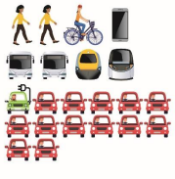
Business as usual would not enable us to achieve the climate change and child poverty targets
Significant active travel projects are being delivered in some of our towns and cities. Local Authorities are continually reviewing how to get the most out of available budgets to support and integrate the public transport options which are available to people.
However, this level of activity is unlikely to be supported by the mechanisms and funding that would provide the active and sustainable travel networks / services required to encourage and ensure significant behavioural change to enable society to hit the interim climate change and child poverty targets by 2030.

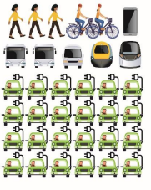
Prioritising active and sustainable travel within existing budgets and with existing resources is unlikely to achieve the climate change and child poverty targets
Partners could potentially squeeze more active and sustainable travel delivery through improved co-ordination across all programmes (and across partner programmes) and a concerted focus on delivering improvements only where they will have the greatest impact on respective targets. However:
- There remains little discretionary spend to provide significantly more active and sustainable travel measures due to the pressures of maintaining and safely operating existing assets
- Limited improvements would be able to be made on providing public transport choices for people not in commercially viable corridors
- More demand management could be undertaken, but politicians are understandably reluctant to introduce restrictions when there are not considered to be reasonable alternatives, and where proportionate restrictions are not applied across a wider area
- Can we do more within existing parameters, such as greater collaboration, and if so, why isn’t this already being done?
Accordingly, there is significant risk in achieving the targets by 2030 if we simply working within current parameters.
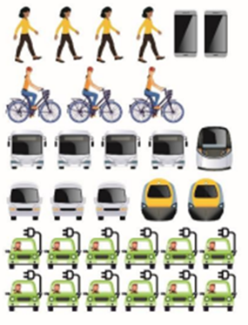
What is hitting or bettering the interim climate change and child poverty targets by 2030 likely to mean?
A step change in delivery and behaviour is required. This is likely to mean:
- Significant change in travel habits for individuals and businesses. This is likely to require significant behavioural change campaigns
- Additional finances (public and private) must be found to improve active travel opportunities and public transport services which enable people to switch from the car
- It is unlikely that carrots alone will encourage a sufficient modal shift, and demand management measures that reflect people’s realistic choices, will be required. This is likely to require disincentivising private car use by those who have alternative travel options
- The location of services and new development must not be car dependent so as not to add to the problem. All public agencies will also have to consider how to provide services within liveable / 20min neighbourhoods to reduce travel and improve access for everyone
- To maximise available resources, greater collaboration and maximising the co-ordination of partner activities is required
- Commercial public transport services alone may not sufficiently support both modal shift and social inclusion objectives. Local authorities may need to consider powers available in the Transport (Scotland) Act 2019. Alternatives to providing subsidised public transport should also be considered, for example, empowering remote communities to develop and deliver their own transport solutions aligned to their needs.
This is a step change in activity for everyone, and there is an urgency behind the changes if the interim 2030 targets are to be hit or bettered. Accordingly, this level of change would require strong and declared political support.
Only then, would we be on track to deliver the long-term net zero greenhouse emissions.

Question 2: Do you support the general approach outlined above to hit or better the interim climate change and child poverty targets by 2030?

What measures could bring about the change required?
Subject to the strategy approach that is adopted, the final strategy will be delivered by more, or less, of the measures identified below.
Summary of Potential Measures
Delivery Theme | Potential Measures
Improving safety | Reduce speeds  Provide road safety education  Improving rest and welfare facilities for hauliers
Influencing travel choices and behaviour | Promoting smarter choices  Parking controls, road space re-allocation and traffic management  Road user charging
Improving access to public transport | Improved public transport interchange  New and improved rail and bus stations  Easier planning and booking of journeys
Improving sustainable travel opportunities | Improving active travel opportunities  Improving active travel to school  Improving public transport  Demand responsive, community and shared transport services  Promote Fair Fares
Decarbonising transport and a just transition | Promoting and enabling electric and low emission vehicles for individuals, public sector, business and bus & coach fleets  Rail decarbonisation  Behaviour change and modal shift for freight
Improving the accessibility & security of our transport networks | Improved accessibility & security of the street environment  Improved accessibility & security for all across public transport
Reducing the need to travel by car through the location of development and services | Reduce car dependency of new developments  Locate new and existing services within communities  Measures in neighbouring authorities that could reduce car use
Improving strategic connectivity | Address pinch points on strategic roads  Improve rail connectivity  Improve connectivity to freight destinations  Improve access to airports
Improving network resilience | Improving network resilience

A detailed description of the individual measures covered by these themes is available at Tactran website

Question 3:
Do you agree with all the delivery themes? Which do you consider are the most important?
Which potential measures don’t you agree with or which may assist you the most? What is the likely impact of the measure on you? Are there potential measures we have not included?

How to respond
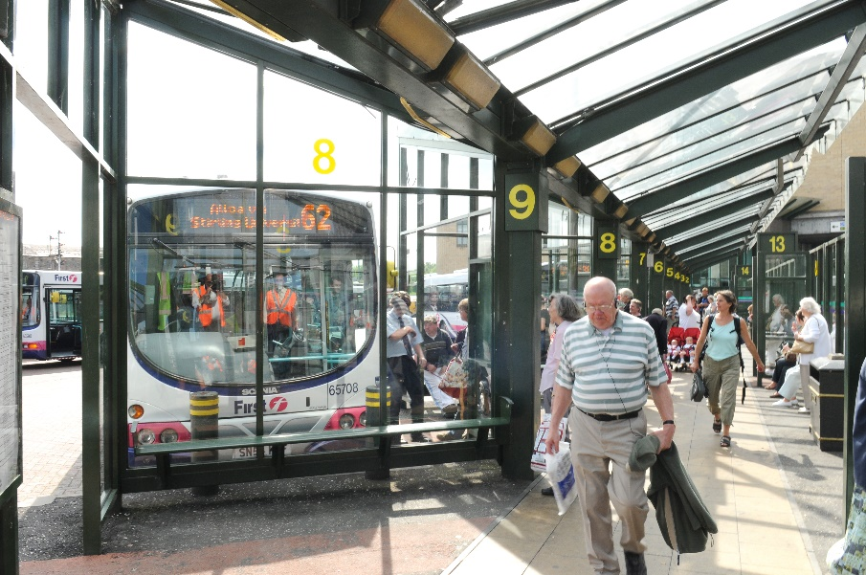
We will be seeking your views on the objectives and outcomes, the scale of change and the potential measures until 4th November 2022.
You can respond to the consultation in a number of ways. On the Tactran website there is:
‘A conversation about changing how we travel’ website: the website provides information about the objectives and potential, and allows you to respond on-line
This long version of ‘a conversation about changing how we travel’ document and questionnaire enabling you to download or copy the questions, and submit a response via post or email
This short version of ‘a conversation about changing how we travel’ document and questionnaire, which contains less questions, and enables you to download or copy the questions, and submit a response via post or email
Please send any responses to:
Info@tactran.gov.uk
Tactran, Bordeaux House, 31 Kinnoull Street, Perth PH1 5EN
If you require help in responding to this consultation, for example a version of the consultation in an easy read format or in an alternative language, please leave a message at Info@tactran.gov.uk or 01738 475775

Q1: Do you agree with the objectives and outcomes?
Question 2: Do you support the general approach outlined in to hit or better the interim climate change and child poverty targets by 2030?

Question 3:
Do you agree with all the delivery themes? Which do you consider are the most important?
Which potential measures don’t you agree with or which may assist you the most? What is the likely impact of the measure on you? Are there potential measures we have not included?
Information about you

If you are responding on behalf of an organisation
Name and/or organisation
First half of your postcode
Could you please outline if your organisation has any responsibility for representing aspects of the environment or groups of people

If you are responding as an individual it will be helpful if you could fill in the box below
Name
First half of your postcode

Your Personal Data and How it will be used: We will be unable to identify you from the information you have provided and all personal information will be destroyed once it has been summarised for the consultation. We will only use your email address if you wish to provide it for the purposes of being kept up to date with the progress of the RTS.
Do you want to be kept informed of the progress of the Regional Transport Strategy?
If you would like to be kept informed of the RTS assessment processes, please write your email address in the box below. This will only be used to forward information to you during the course of writing this RTS and will be deleted immediately thereafter. It will not be stored in relation to any responses you gave in relation to the survey.
Email address

Tactran are one of seven regional transport partnerships established by the Scottish Government. The partnership consists of Angus, Dundee, Perth and Kinross, and Stirling Councils.
A description of the issues can be found in Main Issues website / Main Issues document. A summary of what you told us about the issues can be found in A New RTS January 2022 Update.

