Consultation on a new
Regional Transport Strategy 2023-2033
for the Angus, Dundee City, Perth and Kinross, and Stirling Council areas

A conversation about changing how we travel
Summer 2022
Contents
- Introduction
- The identification of issues, objectives and outcomes
3 The scale of change required
3.1 What scale of change is required and what does it mean to you?
4 What measures could bring about the change required?
4.1 Summary of potential measures
4.2 Which measures will help deliver which objective?
5 Next steps
5.1 How are we going to assess measures?
5.2 How to respond
Annexes
A1. What are your views on the potential measures?
A2. Which measures are most likely where you live
A3. References
If you require help in responding to this consultation, for example a version of the consultation in an easy read format or in an alternative language, please leave a message at Info@tactran.gov.uk or 01738 475775
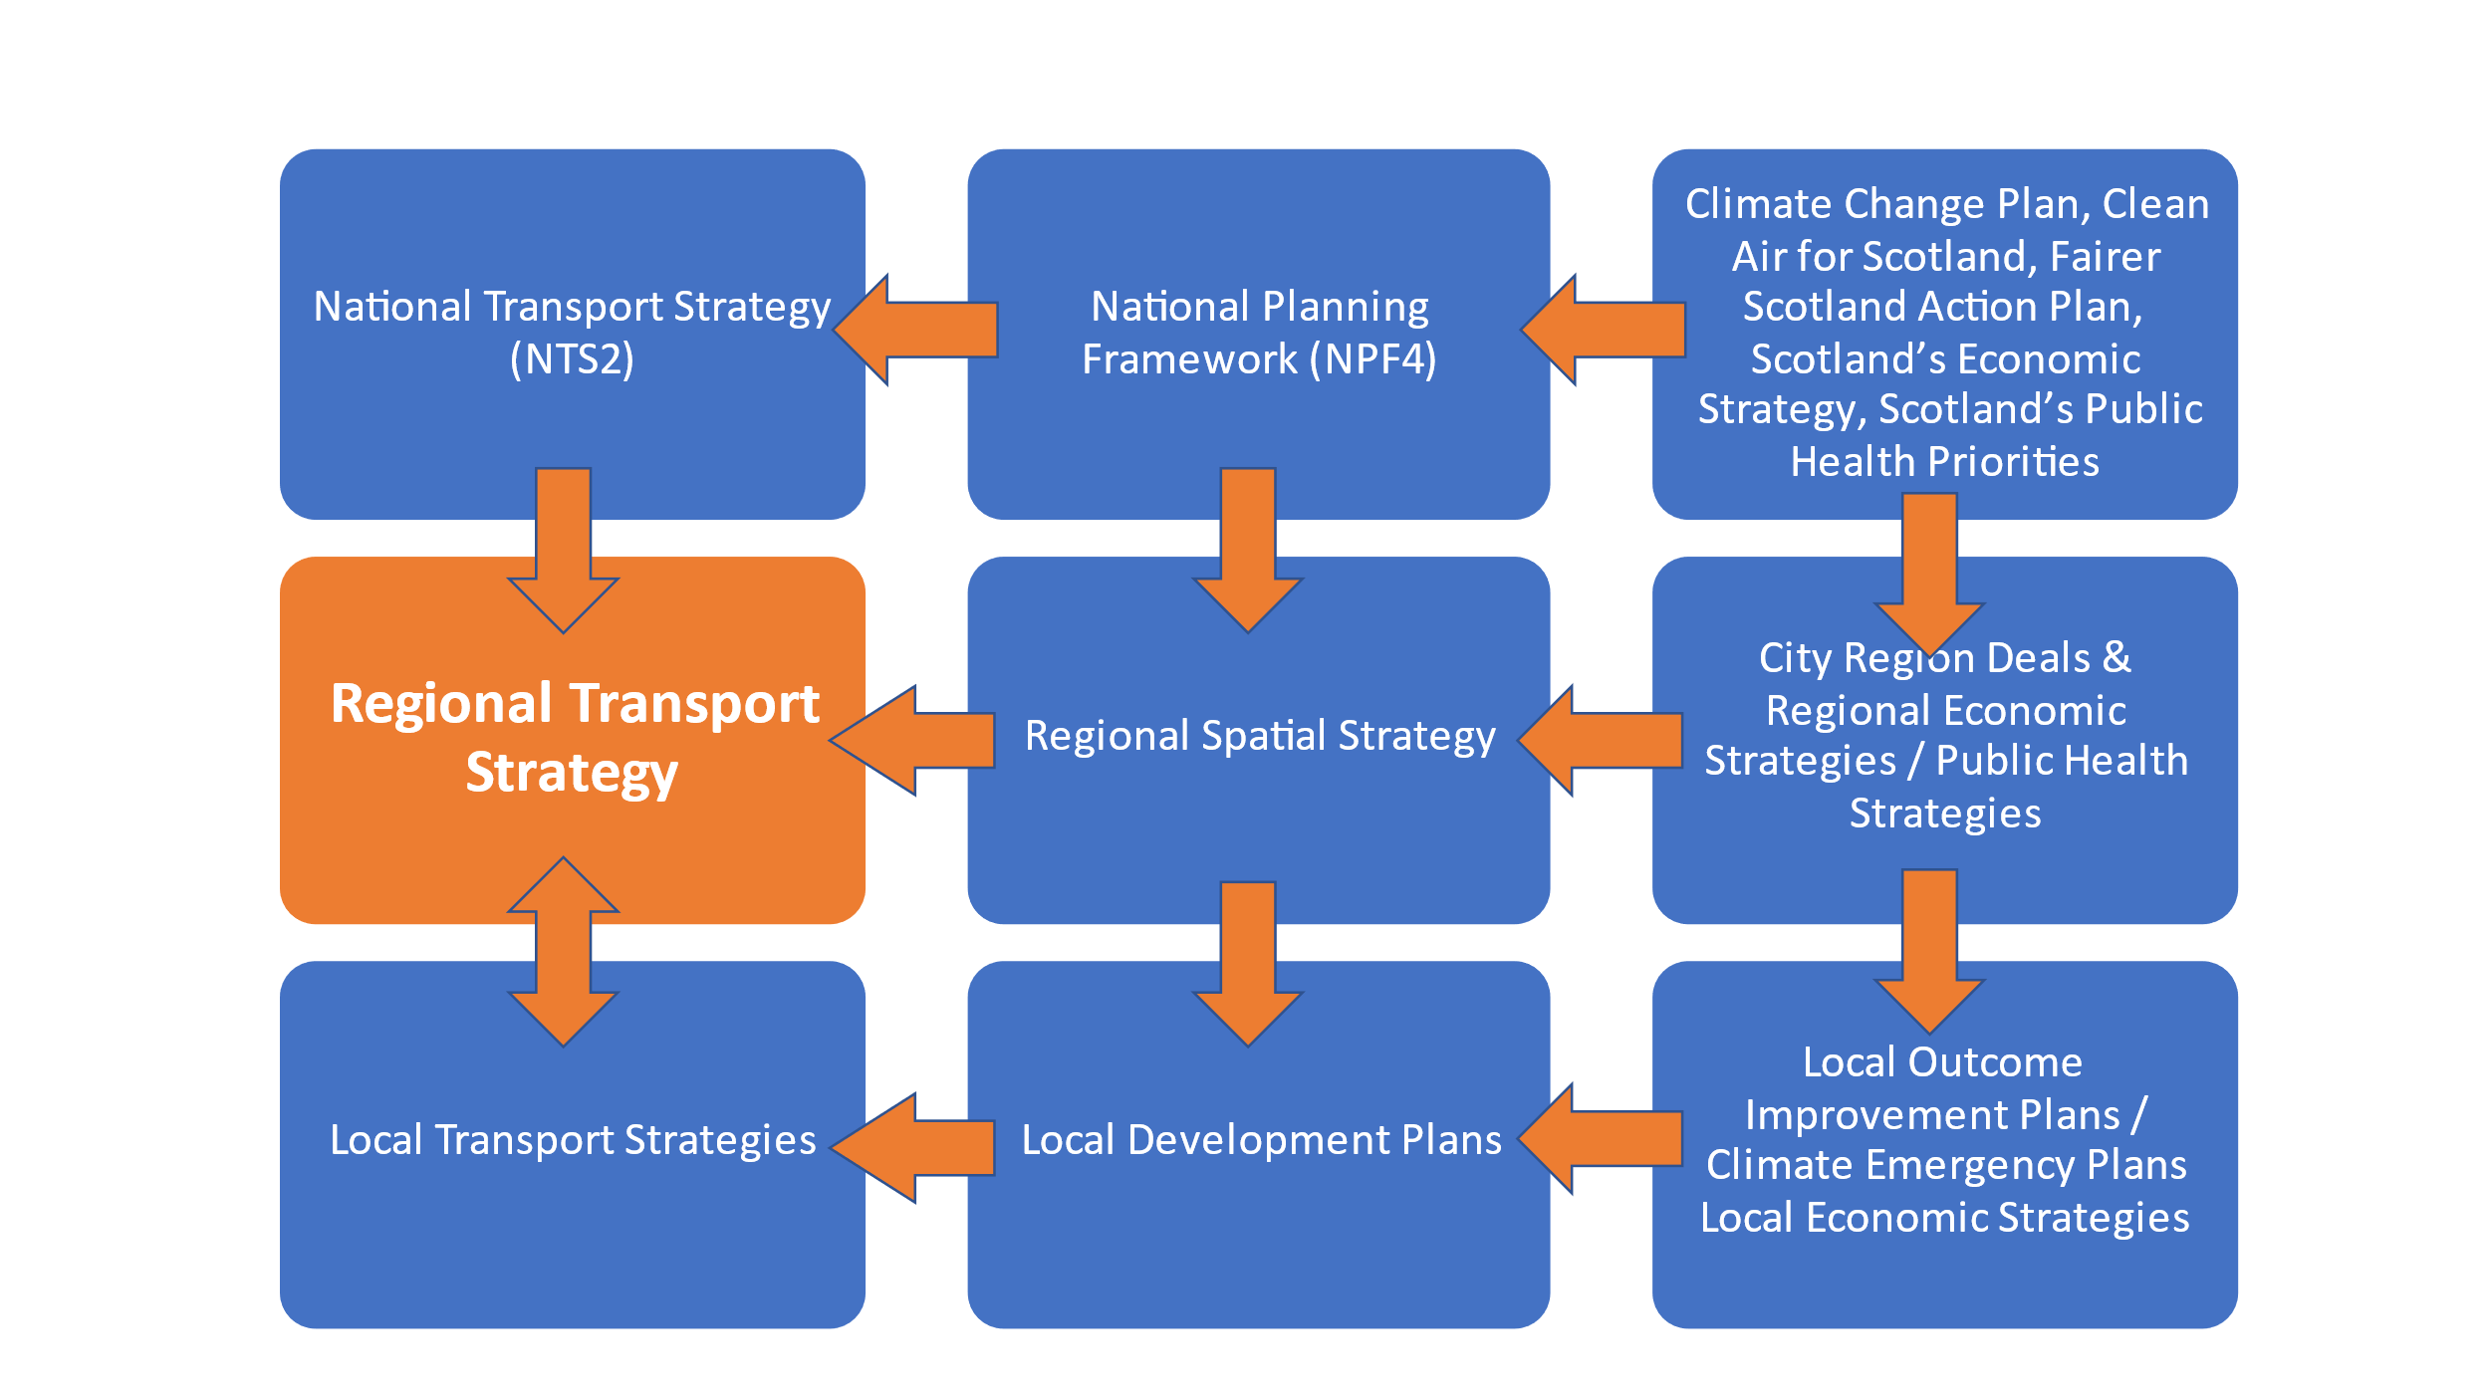
1 Introduction
A conversation about changing how we travel
Tactran are preparing a new Regional Transport Strategy for the area covering Angus, Dundee City, Perth & Kinross and Stirling Councils.
National targets relating to Climate Change mean we all need to consider how we change when and how we travel.
To inform the draft strategy, which we expect to consult on during 2023, we want to understand how you feel about the measures which could help deliver the national targets and the Regional Transport Strategy’s objectives.

The identification of issues, objectives and outcomes
Fig 1 RTS development process
During Summer 2021 we sought your views on the issues that should shape the strategy. These issues then shaped the draft objectives and outcomes for the strategy.
We want your views on whether these objectives and outcomes will help address the key transport related issues in the region.

Potential Measures
We then drafted a list of measures that could deliver these objectives and outcomes.
But the measures alone are just the potential building bricks for the strategy. The scale, timing and packaging of the measures will be critical in what can be achieved and by when.
So, we want your views on:
- The scale of change required, and what this will mean for you
- The extent to which individual measures can help deliver the objectives and outcomes, and hence address the issues identified
2 The identification of issues, objectives and outcomes
During Summer 2021 we sought your views on the issues that should shape the strategy. These issues were taken into account in setting the following draft objectives for the strategy
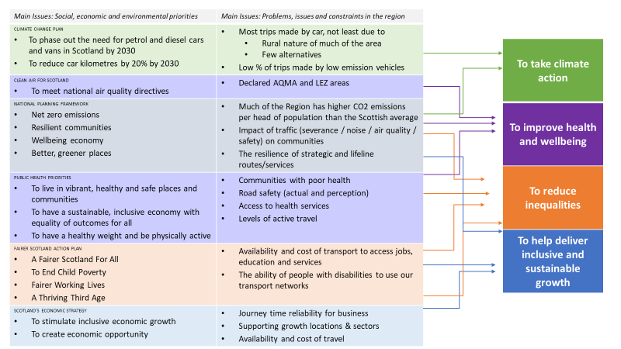
Fig2: Issues and Objectives
A fuller description of the issues can be found in Main Issues website / Main Issues document. A summary of what you told us about the issues can be found in A New RTS January 2022 Update
Nonetheless, it is useful to remind ourselves of relevant national targets that outline the scale of the challenge.
Decarbonisation of transport: reduce transport carbon emissions by 75% by 2030
- phasing out need for new petrol or diesel light commercial vehicles in public bodies by 2025
- phasing out need for any new petrol or diesel vehicles in public sector fleets by 2030
- phasing out need for new petrol or diesel cars or vans by 2030
- removal of diesel passenger trains from the Scottish network by 2035

Reducing car km
- To reduce car km driven by 20% by 2030

Child poverty: by 2030, of children living in Scottish households:
- less than 10% should be living in relative poverty (how many families are on low incomes compared with middle income households) (2021 24%)
- less than 5% should be living in absolute poverty (how many low income families are not seeing their living standards improving over time) (2021 22%)
- less than 5% should be living with combined low income and material deprivation (how many lower income families cannot afford basic necessities) (2021 13%)
- less than 5% should be living in persistent poverty (how many families live on low incomes three years out of four) (2021 16%)

Referring back to the issues across the region, we then identified draft outcomes to focus attention on what actions will help achieve the objectives. Under each primary outcome is nested one or more secondary outcomes to help focus activity on where it is most needed in the Region.
Table1: Draft Objectives and Primary Outcomes
Objectives (draft) | Primary Outcomes (draft)
To take climate action | Reduce greenhouse gas emissions
 | Modal shift to more sustainable modes of travel
 | Reduce car mileage
 | Ensure our transport networks are resilient
To improve health and wellbeing | Reduce fatalities and injuries
 | Improve air quality
 | Improve ability for older people and disadvantaged communities to access healthcare
 | Improve ability for the most vulnerable to access social activities
 | Increase levels of physical activity
To reduce inequalities | Improve ability for young people, and disadvantaged & rural communities to access jobs, education and services
To help deliver sustainable, inclusive economic growth | Reliable inter and intra-regional journey times
 | Improve ability for young and disadvantaged communities to access jobs, education and training

Table2: Climate action secondary outcomes
Primary Outcome (draft) | Secondary Outcome (draft) | The scale of issue
1.1 Reduced greenhouse gas emissions | 1.1.1 Increase the share of EV and low emission vehicle use | Less than 1% of vehicles registered in the Tactran region were electric (2020)
 | 1.1.2 Reduce estimated CO₂ emissions from transport in the region | Angus, Perth and Kinross and Stirling all have higher per capita transport CO2 emissions compared to the Scottish average (2019)
1.2 Modal shift to more sustainable modes of travel | 1.2.2 Personal travel: Increase the share of trips made by sustainable modes such as walking, cycling and public transport | 60% of trips made by those living in the region are made by car (2019)
 | 1.2.3 Reducing freight mileage by road | Freight traffic accounts for 26% of the vehicle mileage in the Region (2019)
1.3 Reduced car km | 1.3.1 Reducing the number and/or length of trips by car | In Angus, Perth and Kinross and Stirling, whilst 21%-32% of trips are over 10km, these trips account for 74%-82% of total km. In Dundee 91% of the trips are under 10km (2019)³
1.4 Ensure our transport networks are resilient | 1.4.1 Ensure strategic and lifeline routes (& services) are resilient to climate change and emergencies | 37% of the region live in rural areas, most of whom are dependent on strategic routes to access jobs, services and healthcare (2016)

Table 3: Improving health and wellbeing secondary outcomes
Primary Outcome (draft) | Secondary Outcome (draft) | The scale of issue
2.1 Reduced fatalities and injuries | 2.1.1 Improve road safety for vulnerable users | Scotland’s Road Safety Framework to 2030 targets pedestrians, cyclists, motorcyclists, road users over 70, 17-25yr olds, children under 16 and people in the lowest 10% SIMD areas
2.2 Reduce the impact of traffic on communities | 2.2.1 Reduce transport emissions in declared air quality management areas | Air quality in Crieff, Dundee and Perth City have all exceeded national thresholds resulting in the declaration of air quality management areas, and in Dundee, a Low Emission Zone
 | 2.2.2 Reduce the impact of traffic on communities on strategic routes | Many communities are sited on trunk roads and regionally significant routes and are subject to the traffic volumes these routes bring
2.3 Improved ability for older people and disadvantaged communities to access healthcare | 2.3.1 improve the ability of over 65s to access healthcare (Primary health care /Hospitals) | In Angus, Perth and Kinross and Stirling approximately 10% of the population do not have public transport access to either primary health care or a hospital (2018)
 | Ability of all in the lowest SIMD datazones (health domain) targeted by the respective Council to access healthcare. See 3.1.2 | Most of the areas in the lowest SIMD datazones (health domain) have good access to a hospital. However, in Angus approx. 60% of those in the lowest 20% of SIMD datazones are over 60mins travel time to a hospital⁷
 | Ability of rural communities to access healthcare. See 3.1.4 | Approximately 13% of those living in Perth and Kinross, 10% living in Angus and Stirling, cannot access primary health care by public transport (2018)⁷
2.4 Improved ability for the most vulnerable to access social activities | 2.4.1 Ability of rural communities and those in the lowest SIMD datazones targeted by the respective Council to access social activities | Poverty is the single biggest driver of poor mental health / The challenge presented by isolation is keenly felt by many in our rural communities
2.5 Increased levels of physical activity | 2.5.1 Improve the levels of walking and cycling in the lowest SIMD datazones (health domain) targeted by the respective Council | 57% of people in the 20% most deprived areas regularly walk as a mode of travel, compared to 78% of people in the least 20% deprived areas
 | 2.5.2 Improved ability to access active leisure facilities and green space for the lowest SIMD datazones (health domain) targeted by the respective Council | Most of the lowest SIMD datazones are able to access leisure facilities by public transport within an hour (2018) during the day. However, the availability of services in the evenings and at weekends are drastically reduced.⁷

Table4: Reducing inequalities secondary outcomes
Primary Outcome (draft) | Secondary Outcome (draft) | The scale of issue
3.1 Improved ability for young people, and disadvantaged and rural communities to access jobs, education and services | 3.1.1 Improve ability of young people to access jobs and further education | 5.5% of 16-19yr olds are not participating in education, training or employment (2021). 8.3% 16-24 year olds do not have public transport access to further education (2018) ⁷
 | 3.1.2 Improve ability of all in the lowest SIMD datazones (all domains) targeted by the respective Council to access jobs, education and services (inc. healthcare) | 36% of the population of Dundee, and 7%, 6% and 12% of Angus, Perth and Kinross and Stirling residents live in the lowest 20% of SIMD datazones (2020)
 | 3.1.3 Improve ability of families targeted in local child poverty action plans to access jobs, education and services | 20.6% of children in Angus, 22.5% in Dundee, 18.7% in Perth and Kinross and 18.1% in Stirling are living in relative poverty (2021)
 | 3.1.4 Improve ability of rural communities to access jobs, education and services (inc. healthcare) | 67.3% of people living in Perth and Kinross, 46.9% of Stirling and 38.4% of Angus live in rural areas (2016)
 | 3.1.5 Ability of people with disabilities to access jobs, education and services | Nearly 9% of people in the Region are limited a lot by a long-term health problem or disability (2011)¹⁰
 | 3.1.6 The safety and security of vulnerable and protected characteristic groups walking / on public transport | In Angus and Dundee, respectively, 9% and 1% feel unsafe walking in their neighbourhood after dark (In Perth and Kinross and Stirling this is 4%). For those that have experienced discrimination, this rises to an average of 25% (across Scotland). 24% of people in the region feel unsafe on the bus in the evenings, and 18% feel unsafe on the trains (2019)³

Table5: Delivering sustainable & inclusive economic growth secondary outcomes
Primary Outcome (draft) | Secondary Outcome (draft) | Example of the scale of issue
4.1 Reliable inter and intra-regional journey times | 4.1.1 Improve journey times and journey time reliability on strategic road and rail routes for public transport to key destinations (e.g. major centres and economic locations) | 11% of drivers experience congestion on their journeys (2020)³  The % of trains that arrive at stations within 5mins of their planned arrival time are typically between 80%-90% at the main stations in the region, but this drops to 70% on the West Highland Line (2022)
 | 4.1.2 Improve journey time reliability for freight to key destinations (e.g. major centres and economic locations / air and sea ports) | 37% of UK freight with an origin or destination in Scotland starts, ends or passes through the region (2019)
4.2 Improved ability for young people, and disadvantaged and rural communities to access jobs, education and training | See 3.1.1 – 3.1.5 above

Question 1: Do you agree with the objectives and outcomes?
To answer this question please go to AnnexA1 Section A
3 The Scale of Change Required
Having adopted draft objectives and outcomes, a list of measures was drafted that could deliver these outcomes.
But the measures are just the potential building bricks for the strategy. The scale, timing and packaging of the measures will be critical in what can be achieved and by when.
So, we want your views on the pros and cons of:
- The scale of change required, and what this will mean for you.
- What measures could bring about the change required? And what they will mean to you.

3.1 What scale of change is required and what does it mean for you?
The scale of change required to achieve the national and local climate change aspirations requires significant changes for individuals, businesses, the Councils and other delivery agencies, in how we travel and service provision. The following questions seek to start a conversation of how we can achieve the targets and what it would mean for people, businesses and the delivery agencies including the Councils.
The scale of the challenge we need to address could be reduced or increased subject to external events such as:
- Economic busts and booms…influencing the pace, capacity and willingness for change, as well as the demand for travel
- Technological advancements, enabling society to do things differently
- Public policy responding to economic (e.g. reductions in fuel duty), environmental (climate change) or social (cost of living or child poverty) priorities
- The future of public transport (bus and rail), and whether there are national responses to the issues that public transport is facing
If or when any of these events occur, we will revisit the RTS delivery programme to delay or bring forward measures as appropriate

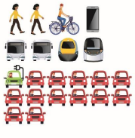
3.1.1 Business as usual would not enable us to achieve the climate change and child poverty targets
Significant active travel projects are being delivered in some of our towns and cities. Local Authorities are continually reviewing how to get the most out of available budgets to support and integrate the public transport options which are available to people.
However, this level of activity is unlikely to be supported by the mechanisms and funding that would provide the active and sustainable travel networks / services required to encourage and ensure significant behavioural change to enable society to hit the interim climate change and child poverty targets by 2030.

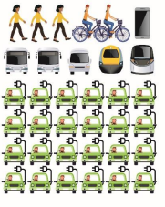
3.1.2 Prioritising active and sustainable travel within existing budgets and with existing resources is unlikely to achieve the climate change and child poverty targets
What changes are required to enable us to maximise existing resources? Partners could potentially squeeze more active and sustainable travel delivery through improved co-ordination across all programmes (and across partner programmes) and a concerted focus on delivering improvements only where they will have the greatest impact on respective targets. However:
- There remains little discretionary spend to target significantly more activity at active and sustainable travel due to the pressures of maintaining and safely operating existing assets
- Limited improvements would be able to be made on providing public transport choices for people not in commercially viable corridors
- More demand management could be undertaken, but politicians are understandably reluctant to introduce restrictions when there are not considered to be reasonable alternatives, and where proportionate restrictions are not applied across a wider area
- Can we do more within existing parameters, such as greater collaboration, and if so, why isn’t this already being done?
Accordingly, there is significant risk in achieving the targets by 2030 if we simply working within current parameters.
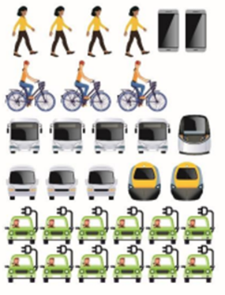
3.1.3 What is hitting or bettering the interim climate change and child poverty targets by 2030 likely to mean?
To achieve a step change in sustainable transport choices by 2030 and ensure:
- People have the choice to make fewer trips by using technology to reduce the need to travel
- People have confidence that they can make car based trips by low emission vehicles and reduce car mileage by making most trips by sustainable modes. Our settlements are healthier places to live….by being less congested, where people are able to access more services locally by walking and cycling
- That everyone has transport opportunities to access jobs, education and services; and that people can easily access public transport to get to, from and between the major centres
- Journey times between centres will be reliable due to less congestion and more resilient networks
Then a step change in delivery and behaviour is required. This is likely to mean:
- Significant change in travel habits for individuals and businesses. This is likely to require significant behavioural change campaigns
- Additional finances (public and private) must be found to improve active travel opportunities and public transport services which enable people to switch from the car
- It is unlikely that carrots alone will encourage a sufficient modal shift, and demand management measures that reflect people’s realistic choices, will be required. This is likely to require disincentivising private car use by those who have alternative travel options
- The location of new development must not be car dependent so as not to add to the problem. All public agencies will also have to consider how to provide services within liveable / 20min neighbourhoods to reduce travel and improve access for everyone
- To maximise available resources, greater collaboration and maximising the co-ordination of partner activities is required
- Commercial public transport services alone may not sufficiently support both modal shift and social inclusion objectives. Local authorities may need to consider powers available in the Transport (Scotland) Act 2019. Alternatives to providing subsidised public transport should also be considered, for example, empowering remote communities to develop and deliver their own transport solutions aligned to their needs.
This is a step change in activity for many transport and public service partners, and there is an urgency behind the changes if the interim 2030 targets are to be hit or bettered. Accordingly, this level of change would require strong and declared political support.
Only then, would we be on track to deliver the long-term net zero greenhouse emissions.

Question 2: Do you support the general approach outlined in 3.1.3 to hit or better the interim climate change and child poverty targets by 2030?
To answer this question please go to AnnexA1 Section B
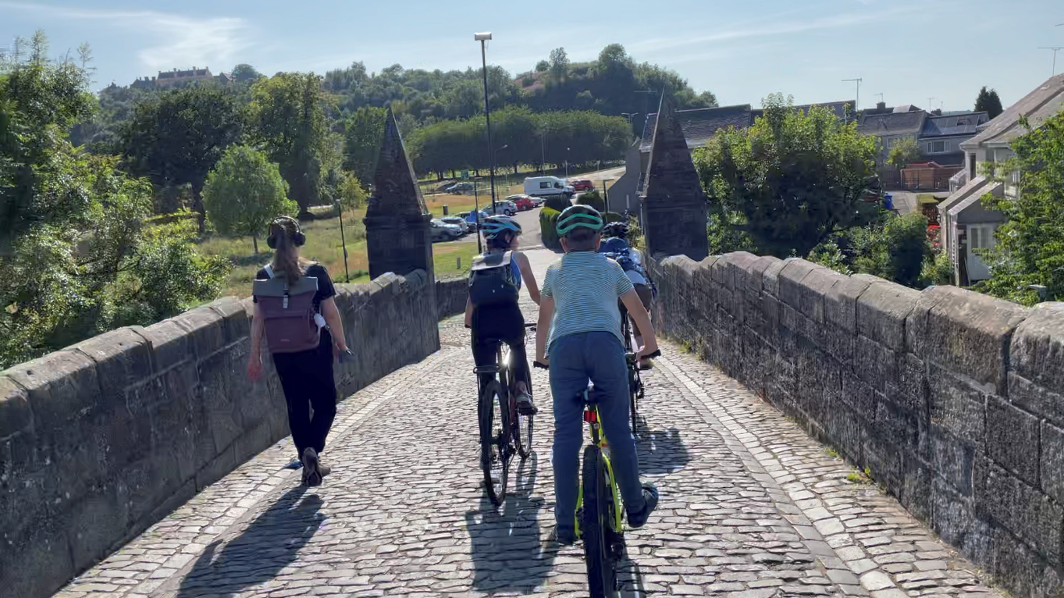
4. What measures could bring about the change required?
4.1 Summary of potential measures
Subject to the strategy approach that is adopted, the final strategy will be delivered by more, or less, of the measures identified in Table 6 below.
Table 6: Summary of Potential Measures
Delivery Theme | Potential Measures
Improving safety | Reduce speeds (view options)  Provide road safety education (view options)  Improving rest and welfare facilities for hauliers
Influencing travel choices and behaviour | Promoting smarter choices  Parking controls, road space re-allocation and traffic management  Road user charging
Improving access to public transport | Improved public transport interchange  New and improved rail and bus stations  Easier planning and booking of journeys
Improving sustainable travel opportunities | Improving active travel opportunities  Improving active travel to school  Improving public transport  Demand responsive, community and shared transport services  Promote Fair Fares
Decarbonising transport and a just transition | Promoting and enabling electric and low emission vehicles for individuals, public sector, business and bus & coach fleets  Rail decarbonisation  Behaviour change and modal shift for freight
Improving the accessibility & security of our transport networks | Improved accessibility & security of the street environment  Improved accessibility & security for all across public transport
Reducing the need to travel by car through the location of development and services | Reduce car dependency of new developments  Locate new and existing services within communities  Measures in neighbouring authorities that could reduce car use
Improving strategic connectivity | Address pinch points on strategic roads  Improve rail connectivity  Improve connectivity to freight destinations  Improve access to airports
Improving network resilience | Improving network resilience

A detailed description of the individual measures covered by these themes is contained in Annex A1. Your views on the potential measures would be welcomed, including:
Q3 – Q10
- How important you think each delivery theme is?
- Do you agree with all the potential measures in each delivery theme?
- Any comments? Which measures don’t you agree with or which may assist you the most? What is the likely impact of the measure on you? Are there potential measures we have not included
To answer these questions please go to AnnexA1 Section C
4.2 Which measures could help deliver which objective?
Table 7 below indicates which measures are most likely to support which objectives and outcomes. Annex A2 indicates which measures are most likely to have a positive impact on the objectives and outcomes of the RTS in differing locales across the region.
Table 7: Which measures could help which objective
Objective | Outcome | Measure
To take climate action | Reduced greenhouse gas emissions | Improving access to public transport: Improved public transport interchange; New and improved rail and bus stations; Easier planning and booking of journeys  Improving choice and opportunities: Improving active travel opportunities; Improving active travel to school; Improving public transport; Promote fair fares  Decarbonising transport and a just transition: Development of electric and hydrogen vehicle charging and refuelling networks; Promoting and supporting a just transition to zero emission vehicles; Rail decarbonisation; decarbonisation of bus networks; Behaviour change and modal shift for freight  Improving network resilience  Influencing travel choices and behaviour: Promoting smarter choices; Parking controls, road space re-allocation and traffic management; Road user charging  Reducing the need to travel by car through the location of development and services: Reduce car dependency of new developments; Locate new and existing services within communities
 | Modal shift to more sustainable modes of travel
 | Reduced car mileage
 | Ensure our transport networks are resilient
To improve health and wellbeing | Reduced fatalities and injuries | Improving safety and security: Reducing speeds; Road safety education; Improving rest and welfare facilities for hauliers  Improving choice and opportunities: Improving active travel opportunities; Improving active travel to school
 | Reduce the impact of traffic on communities
 | Improved ability for older people and disadvantaged communities to access healthcare
 | Improved ability for the most vulnerable to access social activities
 | Increased levels of physical activity
To reduce inequalities | Improved ability for young people, and disadvantaged & rural communities to access jobs, education and services | Improving access to public transport: Easier planning and booking of journeys  Improving choice and opportunities: Demand responsive, community and shared transport Services; Fares  Improving the accessibility & security of our transport networks: Improved accessibility & security of the street environment; Improved access for all across public transport  Reducing the need to travel by car through the location of development and services: Reduce car dependency of new developments; Locate new and existing services within communities
To help deliver sustainable, inclusive economic growth | Reliable inter and intra-regional journey times | Improving strategic connectivity Address pinch points on strategic roads; Improve rail connectivity; Improve connectivity to freight destinations; Improve access to airports  Improving choice and opportunities: Demand Responsive, Community and shared transport services; Promote fair fares; Improving public transport
 | Improved ability for young and disadvantaged communities to access jobs, education and training
5. Next steps
5.1 How are we going to assess measures?
Your views on the scale of change and the individual measures, will inform the next stage of the work. This will culminate with reporting to the Tactran Partnership on:
- The likely acceptability of measures
- The extent to which measures are likely to deliver the objectives and outcomes identified. This will follow the principles set out in Transport Scotland’s ‘Scottish Transport Appraisal Guidance’ and consider:
  - how the measures will help achieve Draft RTS Objectives and Outcomes
  - deliverability of the measures
This work will also consider how the measures align with the National Transport Strategy’s mode & investment hierarchies
- the impact that measures may have on people and place. This will be considered in Impact Assessments that consider
  - Place, incorporating a Strategic Environmental Assessment
  - People, incorporating
    - Equality and Human Rights Impact Assessment
    - Health Inequalities Impact Assessment
    - Child Rights and Wellbeing Impact Assessment
- Where measures are most likely to have the most positive impact on the objectives and outcomes
This work will assist the Partnership identified a preferred approach which will be incorporated in a draft strategy

5.2 How to respond
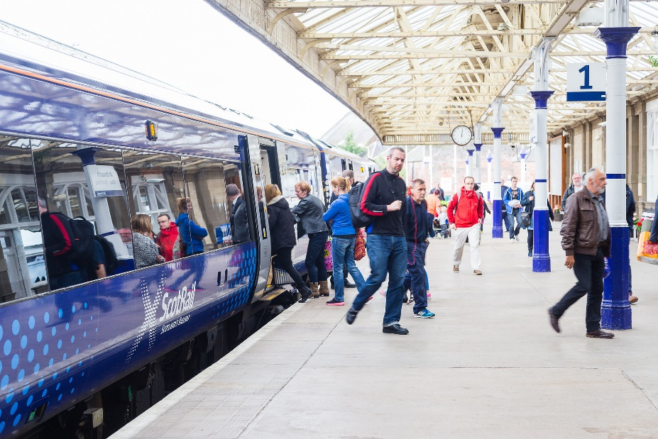
We will be seeking your views on the objectives and outcomes, the scale of change and the potential measures until 4th November 2022.
You can respond to the consultation in a number of ways. On the Tactran website there is:
‘A conversation about changing how we travel’ website: the website provides information about the objectives and potential, and allows you to respond on-line
This long version of ‘a conversation about changing how we travel’ and questionnaire enabling you to download or copy the questions, and submit a response via post or email
A short version of ‘a conversation about changing how we travel’ document and questionnaire, which contains less questions, and enables you to download or copy the questions, and submit a response via post or email
Please send any responses to:
Info@tactran.gov.uk
Tactran, Bordeaux House, 31 Kinnoull Street, Perth PH1 5EN
If you require help in responding to this consultation, for example an alternative version of the consultation in easy read format or in alternative language, please contact us at Info@tactran.gov.uk or 01738 475775

Annex A1
Questions
- Will the proposed objectives and outcomes help address the issues identified?
Question 1: Do you agree with the objectives and outcomes? | Strongly Agree | Agree | Neither agree / disagree | Disagree | Strongly disagree
How strongly do you agree with all the objectives (see Fig 2)
Do the outcomes help support the issues identified?
Which of the objectives and/or outcomes do you feel are the most important to deliver?

If you disagree with any of the objectives or outcomes, please tell us which ones

Do you think that there are any important transport related issues that the objectives or outcomes do not address? If so, please tell us.

Any other comments?

B. Do you support the general approach to hit or better the interim climate change and child poverty targets by 2030?
Question 2: Do you support the general approach outlined in 3.1.3 to hit or better the interim climate change and child poverty targets by 2030? | Strongly Support | Support | Neither support / object | Object | Strongly object
If you object to the approach, why?

What impact would this approach have on you or your organisation?

Is there anything else that we should consider when finalising our approach?

Any other comments?

C. What are your views on the potential measures?
Improving safety
Reduce speeds | - Reducing speeds in settlements  - Expansion of 20mph limits and zones  - Review speed limits in residential and neighbourhood environments focusing on areas with road safety concerns  - Other localised safety schemes such as traffic calming measures and road / junctions realignments and redesigns  - Addressing network blackspots  - Review speed limits  - Road / junction realignments and redesigns  - Road safety enforcement, including enforcement of speed restrictions via camera technology
Provide road safety education | Education measures, which include training and publicity, aiming to provide road users with the knowledge and skills needed to use the roads safely. Focused on:  (i) Road safety education pre-school, primary and secondary schools  (ii) Road safety education for adults, such as drivers  (iii) Road safety education for 17-25yr olds
Improving rest and welfare facilities for hauliers | Increase the range of rest facilities within the region available to drivers  Freight is still predominantly road-based with most drivers regularly traveling long distances. Without sufficient rest, drivers can experience fatigue which can be dangerous for themselves and other road users.

Q3. Improving safety | Strongly Agree | Agree | Neither agree / disagree | Disagree |  | Strongly disagree
How strongly do you agree with the need to improve safety?
Do you agree with all the potential measures to improve safety? |  | Yes |  |  | No
Any comments? Which measures don’t you agree with or which may assist you the most? What is the likely impact of the measure on you? Are there potential measures we have not included?

Influencing travel choices and behaviour
Promoting Smarter Choices | (i) Campaigns to promote active and sustainable travel in Travel to Work Areas  (ii) Develop and deliver Travel Plans and School Travel Plans  (iii) Promoting LiftShare / Ride Sharing schemes
Parking controls, road space re-allocation and traffic management | The attractiveness of car use compared to public transport and active travel modes can be influenced by:  (i) Workplace Parking Levy / Congestion Zone Charging  (ii) Public parking charges  (iii) Reallocation / Reduction of the numbers of both on-street and off-street parking spaces within town centres  (iv) Reallocation of carriageway, giving more space to active and sustainable modes  (v) Re-routing motorised traffic on longer and/or less direct routes for the benefit of the wider network
Road User Charging | Road users could be charged either for the length of trip made or for entering a specific area, such as a city centre, to encourage the use of sustainable modes to make the trip

Q4. Influencing travel choices and behaviour | Strongly Agree | Agree | Neither agree / disagree |  | Disagree |  | Strongly disagree
How strongly do you feel we should be influencing travel choices and behaviour?
Do you agree with all the potential measures to influence travel choices and behaviour? |  | Yes |  |  |  | No
Any comments? Which measures don’t you agree with or which may assist you the most? What is the likely impact of the measure on you? Are there potential measures we have not included

Improving access to public transport
Improved public transport interchange | - Strategic Park and Ride sites to transfer to coach or rail those long-distance car trips heading to Scotland's cities outwith the region  - Local Park and Choose sites to provide interchange facilities at railway stations, bus stations and on public transport corridors serving towns to enable transfer to train, bus or bike into our larger towns and cities  - Mobility Hubs link a number of transport services within a community to improve access via different modes to enable your onward journey. This usually means improving the ability to access bus services by, e.g. car and bicycle parking; bike hire; walking and cycling links; demand responsive bus services. But they could also help accessing car club & car sharing facilities.  - Passenger facilities along strategic bus corridors: ensuring accessible waiting facilities with information along strategic bus corridors
New and improved rail and bus stations | (i) New and improved bus stations  (ii) New and improved rail stations on existing lines
Easier planning and booking of journeys | (i) Journey planning tools to help people be aware of all the choices they have to make a journey  (ii) Smart and integrated ticketing whereby tickets are stored electronically, usually on a smart card or other forms of smart media, enabling a person to use a single 'ticket' on different modes of transportation, such as bus and rail, or across different operators.  MaaS products can provide both improved journey planning and provide smart, integrated ticketing

Q5. Improving access to public transport | Strongly Agree | Agree | Neither agree / disagree | Disagree |  | Strongly disagree
How strongly do you feel we should be improving access to public transport?
Do you agree with all the potential measures to improve access to public transport? |  | Yes |  |  | No
Any comments? Which measures don’t you agree with or which may assist you the most? What is the likely impact of the measure on you? Are there potential measures we have not included

Improving sustainable travel opportunities
Improving active travel opportunities | (i) Connected neighbourhoods, enabling people to access local facilities by walking and cycling  (ii) Active freeways, cycle priority routes into our town and city centres  (iii) Strategic active travel network, providing village-town active travel connections; connecting towns by active travel; and supporting the long-distance active travel network  (iv) Ensuring secure cycle parking at homes, workplaces, schools, interchanges and other destinations  (v) Cycle hire schemes, increasing the number of conventional and electric cycle hire scheme
Promoting active and sustainable access to schools | (i) safer routes to schools - improving walking and cycling routes to schools, including reducing traffic speeds around schools  (ii) school exclusion zones - limiting traffic around schools at peak times to improve safety and air quality for children  (iii) cycle parking; cycle training and improving access to bikes
Improving public transport | (i) Strategic Bus Priority Corridors, improving journey time and reliability through bus priority measures, traffic management etc.  (ii) Increasing Bus Services, improving the frequency and coverage of public transport through fixed routes and feeder services (including DRT and Community Transport)  (iii) Improved rail services
Demand Responsive, Community and shared transport Services | (i) Demand Responsive Transport (DRT): on demand (rather than timetabled services) to link to existing traditional fixed route bus services, and to cover areas where fixed route services are not viable  (ii) Community Transport Services: Support for community and volunteer transport services  (iii) Car Clubs: to provide access to a car without the need to own one
Promote Fair Fares | Fare structures are typically set in a way to make travel during peak times more expensive, with off-peak travel fares offered at lower rates.  Encourage & support public transport providers to review fares to:  (a) enhance social inclusion by providing a realistic alternative to a wider range of people, including disadvantaged communities  (b) help balance demand for public transport throughout the day and reduce pressure on services at peak times

Q6. Improving sustainable travel opportunities | Strongly Agree | Agree | Neither agree / disagree | Disagree |  | Strongly disagree
How strongly do you feel we should be improving sustainable travel opportunities?
Do you agree with all the potential measures to improve sustainable travel opportunities? |  | Yes |  |  | No
Any comments? Which measures don’t you agree with or which may assist you the most? What is the likely impact of the measure on you? Are there potential measures we have not included

Decarbonising transport and a just transition
Promoting and enabling electric and low emission vehicles for individuals, public sector, business and bus fleets | (i) Supporting electric vehicle uptake through adoption of Ultra Low Emission Vehicles (ULEV) in public sector, business and bus fleets; and supporting a just transition through the availability of electric vehicles through car clubs and parking and charging tariffs  (ii) Developing charging infrastructure through deployment and maintenance of public infrastructure; home charging and fleet charging  (iii) Promoting electric mobility, communicating the benefits of low emission vehicles
Rail Decarbonisation | Support the decarbonisation of the rail network by 2035 through  (i) Electrification of Dunblane to Perth / Dundee / Aberdeen  (ii) Battery Electric Trains from Edinburgh to Perth / Dundee (short term)  (iii) Electrification from Edinburgh to Perth / Dundee (long term)  (iv) Electrification from Perth to Inverness (cp. STPR2)  (v) Battery Electric Trains on the West Highland Line
Behaviour change and modal shift for freight | Freight transfer and consolidation hubs within the region to reduce road freight and also allow freight to be moved by rail and water  (i) Freight hubs  (ii) Timber transfer facilities  (iii) Consolidation centres  (iv) First and last mile distribution services, such as vans, drones, cargo bikes etc.

Q7 Decarbonising transport and a just transition | Strongly Agree | Agree | Neither agree / disagree | Disagree |  | Strongly disagree
How strongly do you feel we should be decarbonising transport?
Do you agree with all the potential measures to decarbonise transport? |  | Yes |  |  | No
Any comments? Which measures don’t you agree with or which may assist you the most? What is the likely impact of the measure on you? Are there potential measures we have not included

Improving the accessibility & security of our transport networks
Improved accessibility & security of the street environment | This option seeks to make our settlements places where everyone, especially people with mobility difficulties, can confidently and easily walk, cycle or wheel around  - Step free routes and appropriate crossing facilities, informed by accessibility audits around the 20min neighbourhoods  - Seating  - Lighting and reviewing the design of the public realm to improve security  - Signage and wayfinding  - Number and location of disabled car parking spaces  - Reducing severance & improving active travel on trunk roads through communities  - Promoting changes to our transport networks to people with learning difficulties
Improved accessibility & security for all across public transport | Improving access for all public transport users and particularly for those who are mobility impaired, including:  (i) Improvements at interchanges, step free access, improved seating, improved lighting, security improvements  (ii) Improved accessibility of buses and trains  (iii) Improved information provision for people with mobility issues/passes  (iv) Assistance to public transport users

Q8 Improving the accessibility & security of our transport networks | Strongly Agree | Agree | Neither agree / disagree | Disagree |  | Strongly disagree
How strongly do you feel we should be improving the accessibility & security of our transport networks?
Do you agree with all the potential measures to improve the accessibility & security of our transport networks? |  | Yes |  |  | No
Any comments? Which measures don’t you agree with or which may assist you the most? What is the likely impact of the measure on you? Are there potential measures we have not included

Reducing the need to travel by car through the location of development and services
Reduce car dependency of new developments | Reduce car dependency of new developments by  - development plans promoting land use patterns that reduce the need to travel, and enable travel by sustainable modes  - the development management process ensuring that new development is realistically accessible by a range of modes
Locate new and existing services within communities | locate new and existing services within communities - all public services to work together to improve the range of local services that can be available at a neighbourhood level to support the 20min / liveable neighbourhood principle
Measures in neighbouring authorities that reduce car use | The ease and ability to make many trips will be influenced by the sticks and carrots being applied in neighbouring areas. Where applicable we could work with neighbouring authorities on measures that can reduce the number of vehicular trips

Q9 Reducing the need to travel by car through the location of development and services | Strongly Agree | Agree | Neither agree / disagree | Disagree |  | Strongly disagree
How strongly do you feel we should be reducing the need to travel by car through the location of development and services?
Do you agree with all the potential measures to reduce the need to travel by car through the location of development and services? |  | Yes |  |  | No
Any comments? Which measures don’t you agree with or which may assist you the most? What is the likely impact of the measure on you? Are there potential measures we have not included

Improving strategic connectivity
Address pinch points on strategic roads | Measures focused on road improvements on the key strategic network within the region, focussed on improving journey time reliability and road safety.  - Kingsway Dundee A90/A972  - Broxden and Inveralmond, A9 Perth  - Craigforth, M9 Stirling  - Grade separation of the A9 between Kier and Inverness (Kier, Auchterader)  - Dualling of the A9 north of Perth  - A82 Inverannan – Tarbert
Improve rail connectivity | - Physical and operational improvements to reduce journey times and improve resilience of routes from and through the region to/from Edinburgh; Glasgow; Aberdeen; Inverness; including  - Highland Mainline rail corridor enhancements  - Perth-Dundee-Aberdeen rail corridor enhancements  - Edinburgh/Glasgow – Perth/Dundee rail corridor enhancements  (ii) Improved frequency and capacity of services to Edinburgh and Glasgow, including consideration of intermediate stations  (iii) improve resilience of West Highland line
Improve connectivity to freight destinations | (i) Improving journey time reliability to major freight destinations  (ii) Improving freight capacity on the rail network
Improve access to airports | Promoting sustainable access between the region and Scotland's airports

Q10 Improving strategic connectivity | Strongly Agree | Agree | Neither agree / disagree | Disagree |  | Strongly disagree
How strongly do you feel we should be improving strategic connectivity?
Do you agree with all the potential measures to improve strategic connectivity? |  | Yes |  |  | No
Any comments? Which measures don’t you agree with or which may assist you the most? What is the likely impact of the measure on you? Are there potential measures we have not included

Improving network resilience
Improving Network Resilience | To maintain a transport network within the region which is resilient to disruptive events resulting from the increased risk of extreme weather and flooding, maintaining access for people and resources  - Winter maintenance  - Diversion routes  - Protection of vulnerable sites to flooding / landslips  - Meet environmental standards in construction and maintenance  - Blue-Green Infrastructure  - Strategic road renewal for reliability, resilience and safety

Q10 Improving network resilience | Strongly Agree | Agree | Neither agree / disagree | Disagree |  | Strongly disagree
How strongly do you feel we should be improving network resilience?
Do you agree with all the potential measures to improve network resilience:? |  | Yes |  |  | No
If you don’t agree with all the potential measures, please outline which ones you don’t agree with and why?

D. Information about you

If you are responding on behalf of an organisation
Name and/or organisation
First half of your postcode
Could you please outline if your organisation has any responsibility for representing aspects of the environment or groups of people

If you are responding as an individual
it will be helpful if you could fill in the box below
Name
First half of your postcode

Your personal data and how it will be used: We will be unable to identify you from the information you have provided and all personal information will be destroyed once it has been summarised for the consultation. We will only use your email address if you wish to provide it for the purposes of being kept up to date with the progress of the RTS.

Do you want to be kept informed of the progress of the Regional Transport Strategy?
If you would like to be kept informed of the RTS assessment processes, please write your email address in the box below. This will only be used to forward information to you during the course of writing this RTS and will be deleted immediately thereafter. It will not be stored in relation to any responses you gave in relation to the survey.
Email address

Annex A2
Which measures are most likely where I live?
Whilst most transport problems will occur in most areas, the relative importance of problems will vary between according to where we live or work. Hence, some measures are more applicable in urban areas, and some in rural areas. The tables below intend to give a feel for the types of interventions most likely in rural and urban areas, and along strategic corridors to help identify those measures most likely for where you live.
Urban Areas  Arbroath  Dundee  Forfar  Montrose  Perth  Stirling (inc Bridge of Allan) | Improving safety: Reduce speeds / Provide road safety education
 | Influencing travel choices and behaviour: Promoting smarter choices / Parking controls, road space re-allocation and traffic management / Road user charging
 | Improving access to public transport: Improved public transport interchange / New and improved rail and bus stations / Easier planning and booking of journeys
 | Decarbonising transport and a just transition: Promoting and enabling electric and low emission vehicles for individuals, public sector, business and bus fleets / Rail decarbonisation / Behaviour change and modal shift for freight
 | Improving the accessibility & security of our transport networks: Improved accessibility & security of the street environment / Improved accessibility & security for all across public transport
 | Improving strategic connectivity: Address pinch points on strategic roads / Improve rail connectivity / Improve connectivity to freight destinations
 | Improving network resilience

Rural Areas  West & North Stirling  West and North Perthshire; Kinross-shire  Angus Glens  Angus Mearns  Stirling Eastern Villages  Carse of Gowrie | Improving safety: Reduce speeds / Provide road safety education
 | Improving access to public transport: Easier planning and booking of journeys
 | Improving sustainable travel opportunities: Improving active travel opportunities / Improving active travel to school / Improving public transport / Demand responsive, community and shared transport services / Promote Fair Fares
 | Decarbonising transport and a just transition: Promoting and enabling electric and low emission vehicles for individuals, public sector, business and bus & coach fleets
 | Improving the accessibility & security of our transport networks: Improved accessibility & security of the street environment / Improved accessibility & security for all across public transport
 | Reducing the need to travel by car through the location of development and services: Locate new and existing services within communities
 | Improving strategic connectivity: Improve rail connectivity
 | Improving resilience: Improving network resilience

Strategic Corridors  Dundee-Aberdeen via Forfar  Dundee - Aberdeen via Arbroath  Dundee to Edinburgh / Perth to Edinburgh / Stirling to Edinburgh  Perth to Inverness / Dunfermline / Stirling / Braemar  Stirling to Edinburgh / Glasgow / Perth / Oban and Fort William | Improving safety: Reduce speeds / Improving rest and welfare facilities for hauliers
 | Influencing travel choices and behaviour: Promoting smarter choices / Road user charging
 | Improving sustainable travel opportunities: Improving public transport / Promote Fair Fares
 | Improving access to public transport: Improved public transport interchange / New and improved rail and bus stations / Easier planning and booking of journeys
 | Decarbonising transport and a just transition: Rail decarbonisation / Behaviour change and modal shift for freight / Promoting and enabling electric and low emission vehicles for individuals, public sector, business and bus & coach fleets
 | Improving strategic connectivity: Address pinch points on strategic roads / Improve rail connectivity / Improve connectivity to freight destinations / Improve access to airports
 | Improving resilience: Improving network resilience

Annex A3
References
General
National Performance Framework
Scottish Household Survey Data Explorer
Indicative Regional Spatial Strategies (Forth Valley; Loch Lomond and the Trossachs National Park Authority; Tay City Region)
Local Development Plans (Angus; Cairngorms; Dundee; Loch Lomond and the Trossachs; Perth & Kinross; Stirling)
Scottish Urban Rural Classification 2016
2011 Census

Environment and Climate Change
Climate Change Plan
Clean Air for Scotland 2
Local Authority territorial CO2 emissions estimates 2005-2019 (kt CO2)

Health and Wellbeing
Public Health Priorities
Public Health Scotland
Mental Health Strategy 2017-2027. The Scottish Government's approach to mental health from 2017 to 2027 – a 10 year vision.

Reducing Inequalities
Fairer Scotland Action Plan / Fairer Scotland action plan: progress report 2020
Tackling child poverty: third year progress report 2020-2021
Local Outcome Improvement Plans
Skills Development Scotland Annual Participation Measure for 16 – 19 year olds in Scotland 2021
Local Outcome Improvement Plans (Angus Community Plan 2017-30; Dundee City Plan 2017-2026; Perth & Kinross Community Plan; the Stirling Plan)

Inclusive Economic growth
Scotland’s National Strategy for Economic Transformation

Transport Policy & Information
Scotland’s National Transport Strategy
Strategic Transport Projects Review
Data on all licensed and registered vehicles, produced by Department for Transport
SHS Transport and Travel in Scotland
DfT Road Traffic Statistics

Data on all licensed and registered vehicles, produced by Department for Transport
Local Authority territorial CO2 emissions estimates 2005-2019 (kt CO2)
SHS Transport and Travel in Scotland
DfT Road Traffic Statistics
Scottish Urban Rural Classification 2016
Strategic transport network, RTS 2015-2036 Refresh
Public transport accessibility mapping RTS Monitoring Framework 2018 Progress Report
Mental Health Strategy 2017-2027. The Scottish Government's approach to mental health from 2017 to 2027 – a 10 year vision.
Scottish Household Survey Data Explorer
Skills Development Scotland Annual Participation Measure for 16 – 19 year olds in Scotland 2021
Population Estimates by Scottish Index of Multiple Deprivation(SIMD)
Children in low income families: local area statistics Annual Official Statistics on the number and proportion of children living in low income families
Scottish Urban-Rural Classification
Performance & Reliability | Public Performance Monitoring | ScotRail
Scottish Transport Statistics 2020

